**Practical 1.a**

**Aim:** Create an application to print on screen the output of adding, subtracting, multiplying and dividing two numbers entered by the user in C#.

**Code:**

using System;

using System.Collections.Generic;

using System.Linq;

using System.Text;

using System.Threading.Tasks;

namespace NewPract1a

{

class Program

{

static void Main(string[] args)

{

Console.Write("NAME : SANDESH \n\n");

// Prompt the user to enter the first number

Console.Write("Enter the first number: ");

double num1 = Convert.ToDouble(Console.ReadLine());

// Prompt the user to enter the second number

Console.Write("Enter the second number: ");

double num2 = Convert.ToDouble(Console.ReadLine());

// Perform the operations

double addition = num1 + num2;

double subtraction = num1 - num2;

double multiplication = num1 * num2;

double division = num2 != 0 ? num1 / num2 : double.NaN;

// Display the results

Console.WriteLine($"\nResults:");

Console.WriteLine($"Addition: {num1} + {num2} = {addition}");

Console.WriteLine($"Subtraction: {num1} - {num2} = {subtraction}");

Console.WriteLine($"Multiplication: {num1} * {num2} = {multiplication}");

if (num2 != 0)

{

Console.WriteLine($"Division: {num1} / {num2} = {division}");

}

else

{

Console.WriteLine("Division: Cannot divide by zero.");

}

Console.ReadKey();

}

}

}

**Output:**

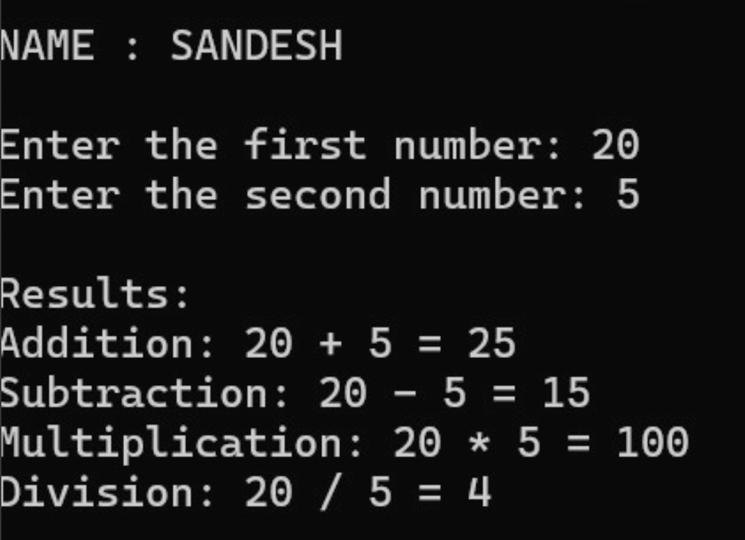

**Practical 1.b**

**Aim:** Create an application to print Floyd’s triangle till n rows in C#.

**Code:**

using System;

using System.Collections.Generic;

using System.Linq;

using System.Text;

using System.Threading.Tasks;

namespace newPract1b

{

class Program

{

static void Main(string[] args)

{

Console.Write("NAME :Sandesh \n\n");

// Prompt the user to enter the number of rows for Floyd's triangle

Console.Write("Enter the number of rows for Floyd's Triangle: ");

int n = Convert.ToInt32(Console.ReadLine());

// Initialize the starting number

int number = 1;

// Generate Floyd's Triangle

Console.WriteLine("\nFloyd's Triangle:");

for (int i = 1; i <= n; i++)

{

for (int j = 1; j <= i; j++)

{

Console.Write(number + " ");

number++;

}

Console.WriteLine(); // Move to the next line after each row

}

Console.ReadKey();

}

}

}

**Output:**

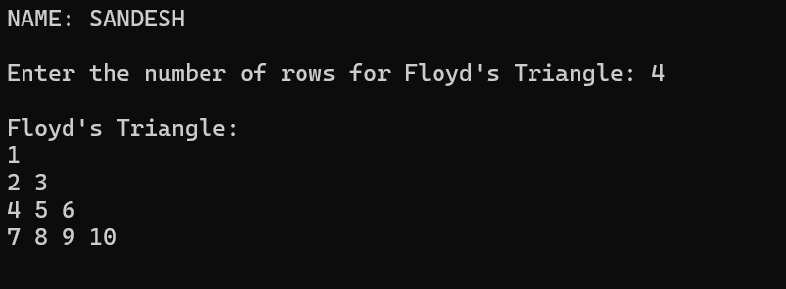

**Practical 1.c**

**Aim:** Create an application to demonstrate following operations

i. Generate Fibonacci series. ii. Test for prime numbers.

**Design:**

**Home Page.aspx**

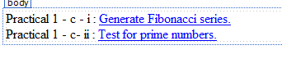

**Source Code:**

<%@ Page Language="C#" AutoEventWireup="true" CodeBehind="Home Page.aspx.cs" Inherits="Pract1_d_.Home_Page" %>

<!DOCTYPE html>

<html xmlns="http://www.w3.org/1999/xhtml">

<head runat="server">

<title></title>

</head>

<body>

<form id="form1" runat="server">

<div>

<asp:Label ID="Label1" runat="server" Text="Practical 1 - c - i :"></asp:Label>

&nbsp;<asp:HyperLink ID="HyperLink1" runat="server" NavigateUrl="~/WebForm1.aspx">Generate Fibonacci series.</asp:HyperLink>

<br />

<asp:Label ID="Label2" runat="server" Text="Practical 1 - c- ii :"></asp:Label>

&nbsp;<asp:HyperLink ID="HyperLink2" runat="server" NavigateUrl="~/WebForm2.aspx">Test for prime numbers.</asp:HyperLink>

<br />

</div>

</form>

</body>

</html>

**WebForm1.aspx (**Generate Fibonacci series.)

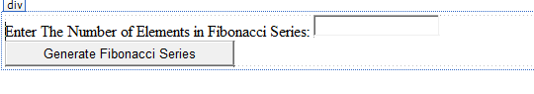

**Source Code:**

<%@ Page Language="C#" AutoEventWireup="true" CodeBehind="WebForm1.aspx.cs" Inherits="Pract1_d_.WebForm1" %>

<!DOCTYPE html>

<html xmlns="http://www.w3.org/1999/xhtml">

<head runat="server">

<title></title>

</head>

<body>

<form id="form1" runat="server">

<div>

<asp:Label ID="Label1" runat="server" Text="Enter The Number of Elements in Fibonacci Series: "></asp:Label>

<asp:TextBox ID="TextBox1" runat="server"></asp:TextBox>

<br />

<asp:Button ID="Button1" runat="server" OnClick="Button1_Click" Text="Generate Fibonacci Series" />

</div>

</form>

</body>

</html>

**WebForm2.aspx (**Test for prime numbers.)

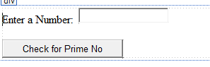

**Source Code:**

<%@ Page Language="C#" AutoEventWireup="true" CodeBehind="WebForm2.aspx.cs" Inherits="Pract1_d_.WebForm2" %>

<!DOCTYPE html>

<html xmlns="http://www.w3.org/1999/xhtml">

<head runat="server">

<title></title>

</head>

<body>

<form id="form2" runat="server">

<div>

<asp:Label ID="Label1" runat="server" Text="Enter a Number:"></asp:Label>&nbsp;

<asp:TextBox ID="TextBox1" runat="server"></asp:TextBox>

<br />

<br />

<asp:Button ID="Button1" runat="server" OnClick="Button1_Click" Text="Check for Prime No" />

</div>

</form>

</body>

</html>

**Code:**

**WebForm1.aspx (**Generate Fibonacci series.)

using System;

using System.Collections.Generic;

using System.Linq;

using System.Web;

using System.Web.UI;

using System.Web.UI.WebControls;

namespace Pract1_d_

{

public partial class WebForm1 : System.Web.UI.Page

{

protected void Page_Load(object sender, EventArgs e)

{

}

protected void Button1_Click(object sender, EventArgs e)

{

int f1 = 0, f2 = 1, f3, n, co;

n = int.Parse(TextBox1.Text);

co = 3;

Response.Write("Fibonacci Series:");

Response.Write(f1+"\t"+f2);

while(co<=n)

{

f3 = f1 + f2;

Response.Write("\t" + f3);

f1 = f2;

f2 = f3;

co++;

}

}

}

}

**WebForm2.aspx (**Test for prime numbers.)

using System;

using System.Collections.Generic;

using System.Linq;

using System.Web;

using System.Web.UI;

using System.Web.UI.WebControls;

namespace Pract1_d_

{

public partial class WebForm2 : System.Web.UI.Page

{

protected void Page_Load(object sender, EventArgs e)

{

}

protected void Button1_Click(object sender, EventArgs e)

{

int n, i, c;

n = int.Parse(TextBox1.Text);

for (c = 2;c<=n-1;c++)

{

if (n % c == 0)

break;

}

if (n == 1)

Response.Write(n + " is neither prime nor composite");

else if (c<n-1)

Response.Write(n + " is not Prime Number");

else

Response.Write(n + " is Prime Number");

}

}

}

**Output**

**Home Page**



**WebForm1.aspx (**Generate Fibonacci series.)

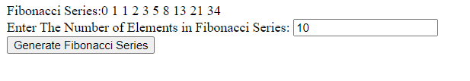

**WebForm2.aspx (**Test for prime numbers.)

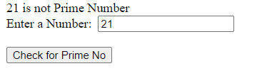

**Practical 2a**

**Aim:** Create a simple application to demonstrate the concepts boxing and unboxing.

**Code:**

using System;

using System.Collections.Generic;

using System.Linq;

using System.Text;

using System.Threading.Tasks;

namespace NewPract2_a_

{

class Program

{

static void Main(string[] args)

{

Console.WriteLine("NAME: Sandesh \n\n");

// Boxing: Converting a value type (int) to an object

int num = 123; // Value type

object obj = num; // Boxing - num is converted to an object

obj = 145;

// Display the boxed value

Console.WriteLine("Boxing:");

Console.WriteLine($"Value type (int): {num}");

Console.WriteLine($"Boxed type (object): {obj}");

// Unboxing: Converting an object back to a value type

int unboxedNum = (int)obj; // Unboxing - obj is converted back to an int

// Display the unboxed value

Console.WriteLine("\nUnboxing:");

Console.WriteLine($"Boxed type (object): {obj}");

Console.WriteLine($"Value type (int): {num}");

Console.WriteLine($"Unboxed type (int): {unboxedNum}");

Console.ReadKey();

}

}

}

**Output**:

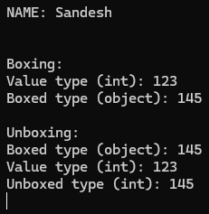

**Practical 2b**

**Aim:** Create a simple application to perform addition and subtraction using delegate

**Code:**

using System;

using System.Collections.Generic;

using System.Linq;

using System.Text;

using System.Threading.Tasks;

namespace NewPract2b

{

// Define a delegate that takes two integers and returns an integer

public delegate int Operation(int x, int y);

class Program

{

// Method to perform addition

public static int Add(int x, int y)

{

return x + y;

}

// Method to perform subtraction

public static int Subtract(int x, int y)

{

return x - y;

}

static void Main(string[] args)

{

Console.Write("NAME: Sandesh \n\n");

// Create delegate instances

Operation addOperation = new Operation(Add);

Operation subtractOperation = new Operation(Subtract);

// Input numbers

Console.Write("Enter the first number: ");

int num1 = int.Parse(Console.ReadLine());

Console.Write("Enter the second number: ");

int num2 = int.Parse(Console.ReadLine());

// Perform addition

int additionResult = addOperation(num1, num2);

Console.WriteLine($"Addition Result: {additionResult}");

// Perform subtraction

int subtractionResult = subtractOperation(num1, num2);

Console.WriteLine($"Subtraction Result: {subtractionResult}");

// Wait for user input before closing

Console.ReadKey();

}

}

}

**Output:**

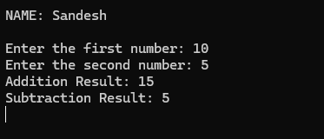

**Practical 2c**

**Aim:** Create a simple application to demonstrate use of the concepts of interfaces.

**Design**:

<%@ Page Language="C#" AutoEventWireup="true" CodeBehind="Interface.aspx.cs" Inherits="NewPract2c.Interface" %>

<!DOCTYPE html>

<html xmlns="http://www.w3.org/1999/xhtml">

<head runat="server">

<title></title>

</head>

<body>

<form id="form1" runat="server">

<div>

<h2> simple application to demonstrate use of the concepts of interfaces. </h2>

<asp:Button ID="Button1" runat="server" OnClick="Button1_Click" Text="Button" />

<h4>NAME: Sandesh </h4>

</div>

</form>

</body>

</html>

**Code**:

using System;

using System.Collections.Generic;

using System.Linq;

using System.Web;

using System.Web.UI;

using System.Web.UI.WebControls;

namespace NewPract2c

{

public interface Itransactions

{

//interface member

string retcode();

double amtfunc();

}

public class Transaction : Itransactions

{

private string tCode;

private double amount;

public Transaction()

{

tCode = "";

amount = 0.0;

}

public Transaction(string c, double a)

{

tCode = c;

amount = a;

}

public double amtfunc()

{

return amount;

}

public string retcode()

{

return tCode;

}

}

public partial class Interface : System.Web.UI.Page

{

protected void Page_Load(object sender, EventArgs e)

{

}

protected void Button1_Click(object sender, EventArgs e)

{

Transaction t1 = new Transaction("Cr", 780.00);

Transaction t2 = new Transaction("Db", 400.00);

Response.Write("<br> Code " + t1.retcode());

Response.Write("<br> Amount " + t1.amtfunc());

Response.Write("<br> Code " + t2.retcode());

Response.Write("<br> Amount " + t2.amtfunc());

}

}

}

**Output:**

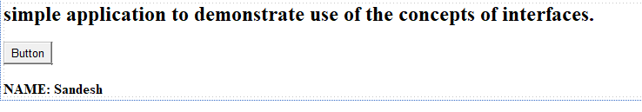

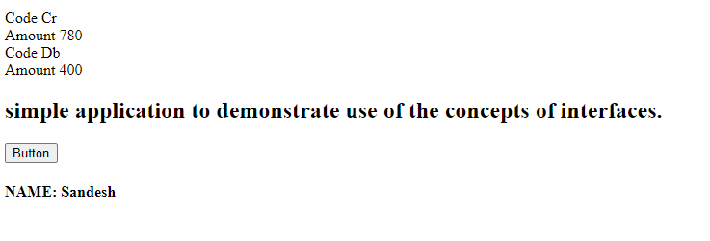

**Practical 3a**

**Aim:** Create a simple web page with various server controls to demonstrate setting and use of their properties. (Example : AutoPostBack)

**Design:**

<%@ Page Language="C#" AutoEventWireup="true" CodeBehind="Pract 3 a.aspx.cs" Inherits="Practical_3.Pract_3_a" %>

<!DOCTYPE html>

<html xmlns="http://www.w3.org/1999/xhtml">

<head runat="server">

<title></title>

<style type="text/css">

.auto-style1 {

width: 50%;

border:3px solid navy;

background-color:#a7a122

}

.auto-style4 {

text-align: center;

height: 46px;

}

.auto-style12 {

height: 47px;

}

.auto-style13 {

width: 215px;

height: 56px;

}

.auto-style14 {

height: 56px;

width: 289px;

}

.auto-style15 {

width: 215px;

height: 54px;

}

.auto-style16 {

height: 54px;

width: 289px;

}

.auto-style17 {

width: 215px;

height: 52px;

}

.auto-style18 {

height: 52px;

width: 289px;

}

.auto-style19 {

width: 215px;

height: 49px;

}

.auto-style20 {

height: 49px;

width: 289px;

}

body{

background-color:#e4cfcf

}

</style>

</head>

<body>

<form id="form1" runat="server">

<div>

<table class="auto-style1">

<tr>

<td class="auto-style13">

<asp:Label ID="Label1" runat="server" Text="RNo"></asp:Label>

</td>

<td class="auto-style14">

<asp:TextBox ID="TextBox1" runat="server" TabIndex="1"></asp:TextBox>

</td>

</tr>

<tr>

<td class="auto-style15">

<asp:Label ID="Label2" runat="server" Text="Name"></asp:Label>

</td>

<td class="auto-style16">

<asp:TextBox ID="TextBox2" runat="server"></asp:TextBox>

</td>

</tr>

<tr>

<td class="auto-style17">

<asp:Label ID="Label3" runat="server" Text="Class"></asp:Label>

</td>

<td class="auto-style18">

<asp:RadioButton ID="RadioButton1" runat="server" Text="FY" GroupName="Class" />

&nbsp;<asp:RadioButton ID="RadioButton2" runat="server" Text="SY" GroupName="Class" />

&nbsp;<asp:RadioButton ID="RadioButton3" runat="server" Text="TY" GroupName="Class" />

</td>

</tr>

<tr>

<td class="auto-style19">

Course</td>

<td class="auto-style20">

<asp:DropDownList ID="DropDownList1" runat="server" AutoPostBack="True" OnSelectedIndexChanged="DropDownList1_SelectedIndexChanged" TabIndex="2">

<asp:ListItem>B.Com</asp:ListItem>

<asp:ListItem>BMS</asp:ListItem>

<asp:ListItem>B.Sc.(I.T.)</asp:ListItem>

<asp:ListItem>B.Sc.(CS)</asp:ListItem>

</asp:DropDownList>

</td>

</tr>

<tr>

<td class="auto-style4" colspan="2">

<asp:Button ID="Button1" runat="server" Text="Submit" OnClick="Button1_Click" AccessKey="S" TabIndex="3" ToolTip="Please Submit Youe Data" />

</td>

</tr>

<tr>

<td class="auto-style12" colspan="2">

<asp:Label ID="Label5" runat="server" Text=" "></asp:Label>

</td>

</tr>

</table>

</div>

</form>

</body>

</html>

**Code:**

using System;

using System.Collections.Generic;

using System.Linq;

using System.Web;

using System.Web.UI;

using System.Web.UI.WebControls;

namespace Practical_3

{

public partial class Pract_3_a : System.Web.UI.Page

{

protected void Page_Load(object sender, EventArgs e)

{

}

protected void Button1_Click(object sender, EventArgs e)

{

string s = "You have been enrolled in ";

if (RadioButton1.Checked == true)

{

s += RadioButton1.Text;

}

else if (RadioButton2.Checked == true)

{

s += RadioButton2.Text;

}

else if (RadioButton3.Checked == true)

{

s += RadioButton3.Text;

}

s += DropDownList1.SelectedItem;

Label5.Text = s;

}

protected void DropDownList1_SelectedIndexChanged(object sender, EventArgs e)

{

Response.Write("You have selected " + DropDownList1.SelectedItem + " Course");

}

}

}

**Output:**

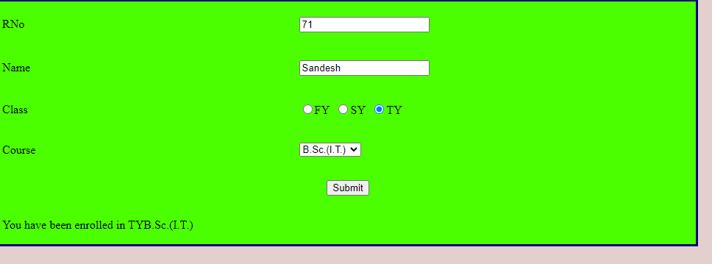

**Practical 3b**

**Aim:** Create a simple application to demonstrate your vacation using calendar control.

**Design:**

<%@ Page Language="C#" AutoEventWireup="true" CodeBehind="Pract 3bb.aspx.cs" Inherits="Practical_3.Pract_3bb" %>

<!DOCTYPE html>

<html xmlns="http://www.w3.org/1999/xhtml">

<head runat="server">

<title></title>

</head>

<body>

<form id="form1" runat="server">

<div>

<asp:Calendar ID="Calendar1" runat="server" NextMonthText="Next" OnDayRender="Calendar1_DayRender" PrevMonthText="Pre" SelectionMode="DayWeekMonth" BackColor="White" BorderColor="White" BorderWidth="1px" Font-Names="Verdana" Font-Size="9pt" ForeColor="Black" Height="190px" NextPrevFormat="FullMonth" OnSelectionChanged="Calendar1_SelectionChanged" Width="350px">

<DayHeaderStyle Font-Bold="True" Font-Size="8pt" />

<NextPrevStyle Font-Bold="True" Font-Size="8pt" ForeColor="#333333" VerticalAlign="Bottom" />

<OtherMonthDayStyle ForeColor="#999999" />

<SelectedDayStyle BackColor="#333399" ForeColor="White" />

<TitleStyle BackColor="White" BorderColor="Black" BorderWidth="4px" Font-Bold="True" Font-Size="12pt" ForeColor="#333399" />

<TodayDayStyle BackColor="#CCCCCC" />

</asp:Calendar>

<h4>NAME: SANDESH </h4>

</div>

</form>

</body>

</html>

**Code:**

using System;

using System.Collections.Generic;

using System.Linq;

using System.Web;

using System.Web.UI;

using System.Web.UI.WebControls;

namespace Practical_3

{

public partial class Pract_3bb : System.Web.UI.Page

{

protected void Page_Load(object sender, EventArgs e)

{

}

protected void Calendar1_DayRender(object sender, DayRenderEventArgs e)

{

if ((e.Day.Date >= new DateTime(2024, 09, 7)) && (e.Day.Date <= new DateTime(2024, 09, 12)))

{

e.Cell.BackColor = System.Drawing.Color.Navy;

e.Cell.BorderColor = System.Drawing.Color.Black;

e.Cell.ForeColor= System.Drawing.Color.White;

e.Cell.BorderWidth = new Unit(3);

if (e.Day.Date == new DateTime(2024, 09, 7))

{

e.Cell.Controls.Add(new LiteralControl("/br Ganpati Vacation Start"));

}

if (e.Day.Date == new DateTime(2024, 09, 12))

{

e.Cell.Controls.Add(new LiteralControl("/br Ganpati Vacation End"));

}

}

}

protected void Calendar1_SelectionChanged(object sender, EventArgs e)

{

if (Calendar1.SelectedDate.Date >= new DateTime(2024, 09, 7) && Calendar1.SelectedDate.Date <= new DateTime(2024, 09, 12))

Response.Write("</br><h1>Ganpati Vacation..... Go to your village and worship Lord Ganesh</h1></br>");

}

}

}

**Output:**

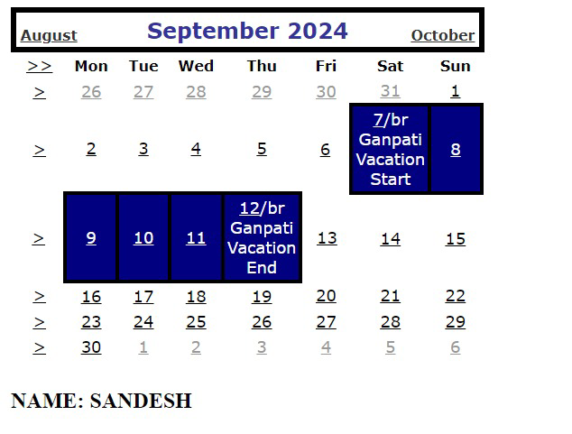

**Practical 3c**

**Aim:** Demonstrate the use of Treeview operations on the web form

**Design:**

<%@ Page Language="C#" AutoEventWireup="true" CodeBehind="Pract3c.aspx.cs" Inherits="Practical_3.WebForm1" %>

<!DOCTYPE html>

<html xmlns="http://www.w3.org/1999/xhtml">

<head runat="server">

<title></title>

</head>

<body>

<form id="form1" runat="server">

<div>

Treeview Contorl Navigation:

<asp:TreeView ID="TreeView1" runat="server" OnSelectedNodeChanged="TreeView1_SelectedNodeChanged" ShowCheckBoxes="All" OnTreeNodeCollapsed="TreeView1_TreeNodeCollapsed" ShowLines="True">

<HoverNodeStyle BackColor="#FF99FF" ForeColor="#003300" />

<LeafNodeStyle BackColor="#99CCFF" ForeColor="#663300" />

<Nodes>

<asp:TreeNode Text="AWP Practical" Value="AWP Practical">

<asp:TreeNode Text="Practical 3" Value="Practical 3">

<asp:TreeNode Text="Practical 3a" Value="Practical 3a" NavigateUrl="~/Pract 3 a.aspx" Target="new"/>

<asp:TreeNode Text="Practical 3b" Value="Practical 3b" NavigateUrl="~/Pract 3 b.aspx">

<asp:TreeNode Text="Practical 3b b" Value="Practical 3b b" NavigateUrl="~/Pract 3bb.aspx"></asp:TreeNode>

<asp:TreeNode Text="Practical 3bc" Value="Practical 3bc" NavigateUrl="~/Pract3bd.aspx"></asp:TreeNode>

</asp:TreeNode>

<asp:TreeNode Text="Practical 3c" Value="Practical 3c"></asp:TreeNode>

</asp:TreeNode>

<asp:TreeNode Text="Website" Value="Website">

<asp:TreeNode Text="Mumbai University" Value="Mumbai University" NavigateUrl="https://mu.ac.in/">

<asp:TreeNode Text="GD Jalan" Value="GD Jalan" NavigateUrl="https://gdjalan.edu.in/"></asp:TreeNode>

</asp:TreeNode>

</asp:TreeNode>

</asp:TreeNode>

</Nodes>

<ParentNodeStyle BackColor="#66FF99" ForeColor="#000099" />

<RootNodeStyle BackColor="#FFFF99" ForeColor="#990000" />

<SelectedNodeStyle BackColor="Black" ForeColor="White" />

</asp:TreeView>

<br />

<br />

<asp:Label ID="Label1" runat="server" BackColor="#FFFF99" Font-Bold="True" Font-Size="20pt"></asp:Label>

<br />

<br />

<br />

<h4>NAME: Sandesh </h4>

</div>

</form>

</body>

</html>

**Code:**

using System;

using System.Collections.Generic;

using System.Data;

using System.Linq;

using System.Web;

using System.Web.UI;

using System.Web.UI.WebControls;

namespace Practical_3

{

public partial class WebForm1 : System.Web.UI.Page

{

protected void Page_Load(object sender, EventArgs e)

{

/*if (!IsPostBack)

{

BindData();

}

}

protected void BindData()

{

DataSet ds = new DataSet();

ds.ReadXml(Server.MapPath("XMLFile1.xml"));

if (ds!= null && ds.HasChanges())

{

DataList1.DataSource = ds;

DataList1.DataBind();

}

else

{

DataList1.DataBind();

}*/

}

protected void TreeView1_SelectedNodeChanged(object sender, EventArgs e)

{

Label1.Text = "You have selected the option:" + TreeView1.SelectedValue;

}

protected void TreeView1_TreeNodeCollapsed(object sender, TreeNodeEventArgs e)

{

Label1.Text = "The Value Collapsed was:" + e.Node.Value;

}

}

}

**Output:**

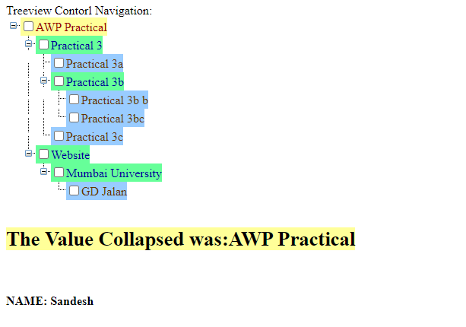

**Practical 4a**

**Aim:** Create a Registration form to demonstrate use of various Validation controls.

**Design:**

<%@ Page Language="C#" AutoEventWireup="true" CodeBehind="4aValidate Contorl Form.aspx.cs" Inherits="Pract_4_a.Validate_Contorl_Form" %>

<!DOCTYPE html>

<html xmlns="http://www.w3.org/1999/xhtml">

<head runat="server">

<title></title>

</head>

<body>

<form id="form1" runat="server">

<div>

<asp:Label ID="Label1" runat="server" Text="Enter Password"></asp:Label>

&nbsp;<asp:TextBox ID="TextBox1" runat="server" TextMode="Password"></asp:TextBox>

&nbsp;<asp:RequiredFieldValidator ID="RequiredFieldValidator1" runat="server" ControlToValidate="TextBox1" ErrorMessage="Password Required" ForeColor="Red">*</asp:RequiredFieldValidator>

&nbsp;<br />

<br />

<asp:Label ID="Label2" runat="server" Text="Confirmed Password"></asp:Label>

<asp:TextBox ID="TextBox2" runat="server" TextMode="Password"></asp:TextBox>

<asp:RequiredFieldValidator ID="RequiredFieldValidator2" runat="server" ControlToValidate="TextBox2" ErrorMessage="Confirm Password Required" ForeColor="Red">*</asp:RequiredFieldValidator>

<asp:CompareValidator ID="CompareValidator1" runat="server" ControlToCompare="TextBox1" ControlToValidate="TextBox2" ErrorMessage="Confirm Password Should Match with password">Confirm Password Should Match with password</asp:CompareValidator>

<br />

<br />

<asp:Label ID="Label3" runat="server" Text="Enter Your Age "></asp:Label>

&nbsp;<asp:TextBox ID="TextBox3" runat="server"></asp:TextBox>

&nbsp;<asp:RequiredFieldValidator ID="RequiredFieldValidator3" runat="server" ControlToValidate="TextBox3" ErrorMessage="Age Required" ForeColor="Red">*</asp:RequiredFieldValidator>

<asp:RangeValidator ID="RangeValidator1" runat="server" ControlToValidate="TextBox3" ErrorMessage="Age Should be between 21 to 30" MaximumValue="30" MinimumValue="21">Age Should be between 21 to 30</asp:RangeValidator>

<br />

<br />

<asp:Label ID="Label4" runat="server" Text="Enter Your Emai ID"></asp:Label>

&nbsp;<asp:TextBox ID="TextBox4" runat="server"></asp:TextBox>

&nbsp;<asp:RequiredFieldValidator ID="RequiredFieldValidator4" runat="server" ControlToValidate="TextBox4" ErrorMessage="Email Required" ForeColor="Red">*</asp:RequiredFieldValidator>

<asp:RegularExpressionValidator ID="RegularExpressionValidator1" runat="server" ControlToValidate="TextBox4" ErrorMessage="Please Enter Valid Email" ValidationExpression="\w+([-+.']\w+)*@\w+([-.]\w+)*\.\w+([-.]\w+)*">Please Enter Valid Email</asp:RegularExpressionValidator>

<br />

<br />

<asp:Label ID="Label5" runat="server" Text="user id"></asp:Label>

&nbsp;<asp:TextBox ID="TextBox5" runat="server"></asp:TextBox>

<asp:RequiredFieldValidator ID="RequiredFieldValidator5" runat="server" ControlToValidate="TextBox5" ErrorMessage="User Id Required" ForeColor="Red">*</asp:RequiredFieldValidator>

<asp:CustomValidator ID="CustomValidator1" runat="server" ControlToValidate="TextBox5" ErrorMessage="User Id Length Should be between 7 and 20 characters" OnServerValidate="CustomValidator1_ServerValidate">User Id Length Should be between 7 and 20 characters</asp:CustomValidator>

<br />

<asp:ValidationSummary ID="ValidationSummary1" runat="server" />

<br />

<br />

<asp:Button ID="Button1" runat="server" OnClick="Button1_Click" Text="Button" />

<br />

<br />

</div>

</form>

</body>

</html>

**Code:**

using System;

using System.Collections.Generic;

using System.Linq;

using System.Web;

using System.Web.UI;

using System.Web.UI.WebControls;

namespace Pract_4_a

{

public partial class Validate_Contorl_Form : System.Web.UI.Page

{

protected void Page_Load(object sender, EventArgs e)

{

}

protected void Button1_Click(object sender, EventArgs e)

{

Response.Write("Submitted");

}

protected void CustomValidator1_ServerValidate(object source, ServerValidateEventArgs args)

{

string str = args.Value;

args.IsValid=false;

if (str.Length < 7 || str.Length > 20)

args.IsValid = false;

else

args.IsValid = true;

}

}

}

**Output:**

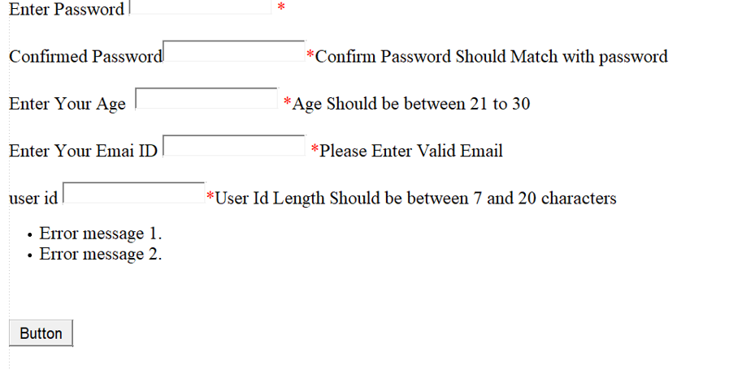

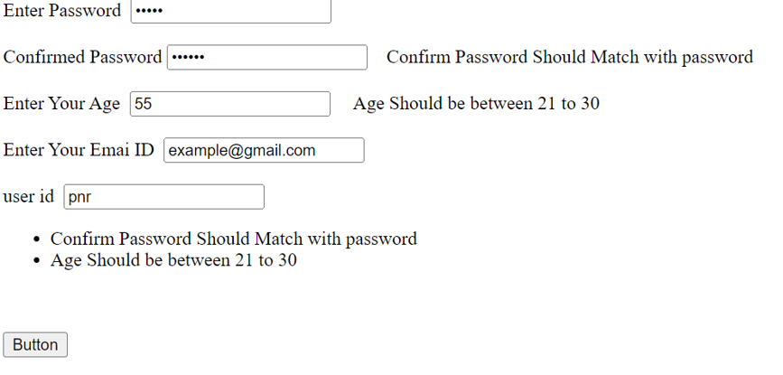

**Practical 4b**

**Aim:** Create Web Form to demonstrate use of Adrotator Control.

**Design:**

<%@ Page Language="C#" AutoEventWireup="true" CodeBehind="Adrotator 4 b.aspx.cs" Inherits="Pract_4_a.Adrotator_4_b" %>

<!DOCTYPE html>

<html xmlns="http://www.w3.org/1999/xhtml">

<head runat="server">

<title></title>

</head>

<body>

<form id="form1" runat="server">

<div>

<asp:AdRotator ID="AdRotator1" runat="server" AdvertisementFile="~/XMLFile1.xml" Target="_blank" />

<br />

<h4>NAME: Sandesh </h4>

</div>

</form>

</body>

</html>

**Code:**

using System;

using System.Collections.Generic;

using System.Linq;

using System.Web;

using System.Web.UI;

using System.Web.UI.WebControls;

namespace Pract_4_a

{

public partial class Adrotator_4_b : System.Web.UI.Page

{

protected void Page_Load(object sender, EventArgs e)

{

}

}

}

**XML file:**

<?xml version="1.0" encoding="utf-8" ?>

<Advertisements>

<Ad>

<ImageUrl>~/Images/Coke.jpg</ImageUrl>

<Impressions>1</Impressions>

<NavigateUrl>https://www.coca-colacompany.com/</NavigateUrl>

<AlternateText>Coke image is missing</AlternateText>

<Keyword>Coke</Keyword>

</Ad>

<Ad>

<ImageUrl>~/Images/Frooti.jpg</ImageUrl>

<Impressions>5</Impressions>

<NavigateUrl>https://gdjalan.edu.in/commerce-faculty-degree-college/ </NavigateUrl>

<Keyword>Frooti</Keyword>

</Ad>

<Ad>

<ImageUrl>~/Images/Pepsi.jpg</ImageUrl>

<Impressions>1</Impressions>

<NavigateUrl>https://www.pepsi.com/</NavigateUrl>

<Keyword>Pepsi</Keyword>

</Ad>

</Advertisements>

**Output:**

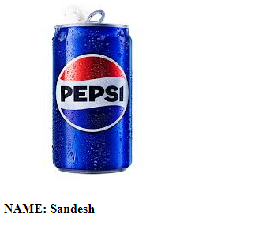

**Practical 4c**

**Aim:** Create Web Form to demonstrate use User Controls

**Design:**

<%@ Page Language="C#" AutoEventWireup="true" CodeBehind="4C.aspx.cs" Inherits="Pract_4_a._4C" %>

<%@ Register src="WebUserControl1.ascx" tagname="MyControl" tagprefix="user" %>

<!DOCTYPE html>

<html xmlns="http://www.w3.org/1999/xhtml">

<head runat="server">

<title></title>

</head>

<body>

<form id="form1" runat="server">

<user:MyControl ID="WebUserControl11" runat="server" />

<div>

<br />

<br />

<asp:Image ID="Image1" runat="server" ImageUrl="~/Images/nature.jpeg" />

<br />

<h4>NAME: SANDESH </h4>

</div>

</form>

</body>

</html>

**Code:**

using System;

using System.Collections.Generic;

using System.Linq;

using System.Web;

using System.Web.UI;

using System.Web.UI.WebControls;

namespace Pract_4_a

{

public partial class _4C : System.Web.UI.Page

{

protected void Page_Load(object sender, EventArgs e)

{

}

}

}

**Output:**

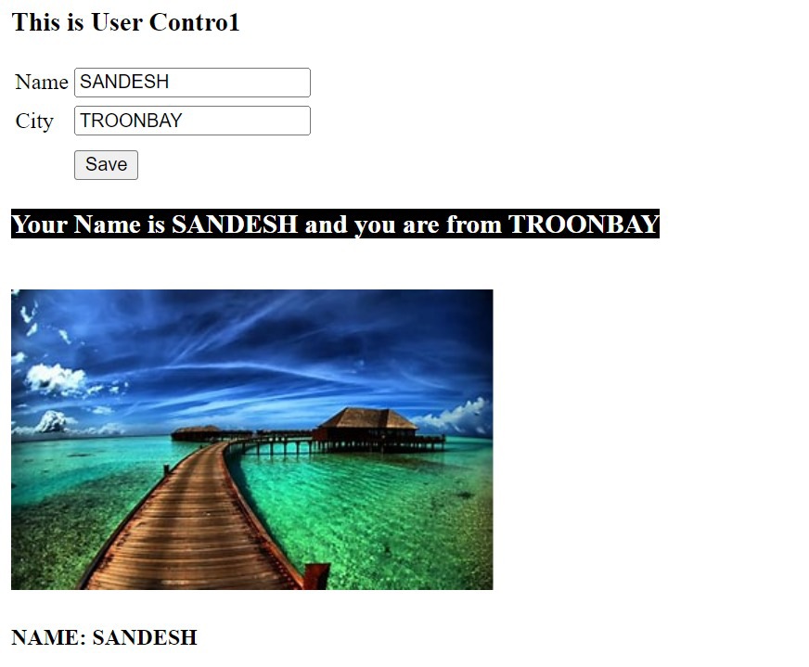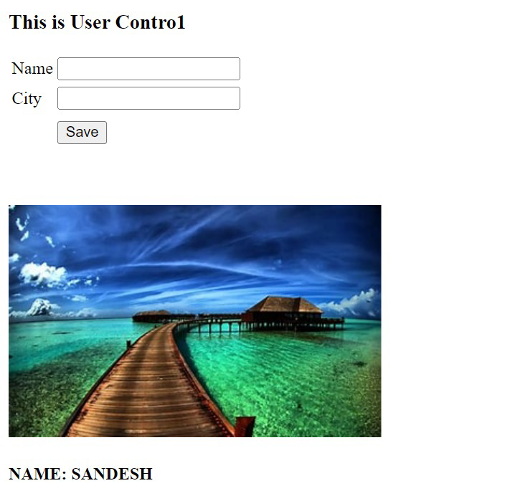

**Practical 5a**

**Aim:** Create Web Form to demonstrate use of Website Navigation controls.

**Design:**

<%@ Page Language="C#" AutoEventWireup="true" CodeBehind="prac_5(A).aspx.cs" Inherits="Pract_4_a.prac_5_A_" %>

<!DOCTYPE html>

<html xmlns="http://www.w3.org/1999/xhtml">

<head runat="server">

<title></title>

<style type="text/css">

.menu {

width: 50%;

height:100px;

border:3px solid navy;

background-color:black;

}

</style>

</head>

<body>

<form id="form1" runat="server">

<div class="menu">

<asp:Menu ID="Menu1" runat="server" DataSourceID="SiteMapDataSource1" DisappearAfter="1000" Font-Bold="True" Font-Size="X-Large" ForeColor="White">

<DynamicHoverStyle BackColor="Black" ForeColor="White" />

</asp:Menu>

</div>

<div><h1>Welcome to our website</h1>

<h3>This is the Home Page</h3> <br/></div>

<asp:SiteMapDataSource ID="SiteMapDataSource1" runat="server" />

<br />

<asp:SiteMapPath ID="SiteMapPath1" runat="server">

<CurrentNodeStyle BackColor="#CCFFCC" />

</asp:SiteMapPath>

<br />

</form>

</body>

</html>

**Page 1:**

<%@ Page Language="C#" AutoEventWireup="true" CodeBehind="Page1.aspx.cs" Inherits="Pract_4_a.Page1" %>

<!DOCTYPE html>

<html xmlns="http://www.w3.org/1999/xhtml">

<head runat="server">

<title></title>

</head>

<body>

<form id="form1" runat="server">

<div>

<h1>Welcome to Page 1 of our website</h1>

</div>

<asp:SiteMapPath ID="SiteMapPath1" runat="server">

</asp:SiteMapPath>

</form>

</body>

</html>

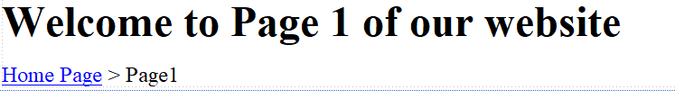

**Page 2:**

<%@ Page Language="C#" AutoEventWireup="true" CodeBehind="Page2.aspx.cs" Inherits="Pract_4_a.Page2" %>

<!DOCTYPE html>

<html xmlns="http://www.w3.org/1999/xhtml">

<head runat="server">

<title></title>

</head>

<body>

<form id="form1" runat="server">

<div>

<h1>Welcome to Page 2 of our website</h1>

</div>

<asp:SiteMapPath ID="SiteMapPath1" runat="server">

</asp:SiteMapPath>

</form>

</body>

</html>

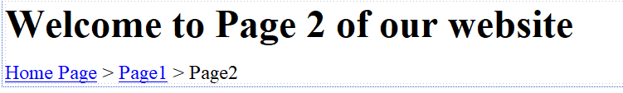

**Page 3:**

<%@ Page Language="C#" AutoEventWireup="true" CodeBehind="Page3.aspx.cs" Inherits="Pract_4_a.Page3" %>

<!DOCTYPE html>

<html xmlns="http://www.w3.org/1999/xhtml">

<head runat="server">

<title></title>

</head>

<body>

<form id="form1" runat="server">

<div>

<h1>Welcome to Page 3 of our website</h1>

</div>

<asp:SiteMapPath ID="SiteMapPath1" runat="server">

</asp:SiteMapPath>

</form>

</body>

</html>

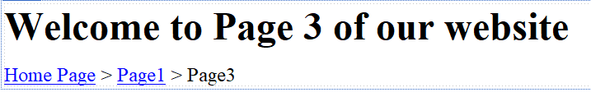

**Page 4:**

<%@ Page Language="C#" AutoEventWireup="true" CodeBehind="Page4.aspx.cs" Inherits="Pract_4_a.Page4" %>

<!DOCTYPE html>

<html xmlns="http://www.w3.org/1999/xhtml">

<head runat="server">

<title></title>

</head>

<body>

<form id="form1" runat="server">

<div>

<h1>Welcome to Page 4 of our website</h1>

</div>

<asp:SiteMapPath ID="SiteMapPath1" runat="server">

</asp:SiteMapPath>

</form>

</body>

</html>

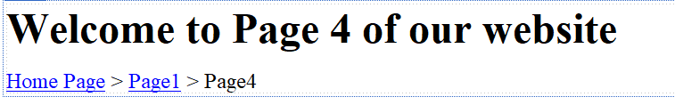

**Output:**

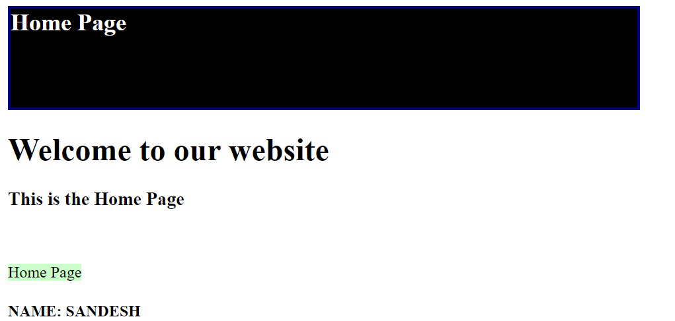

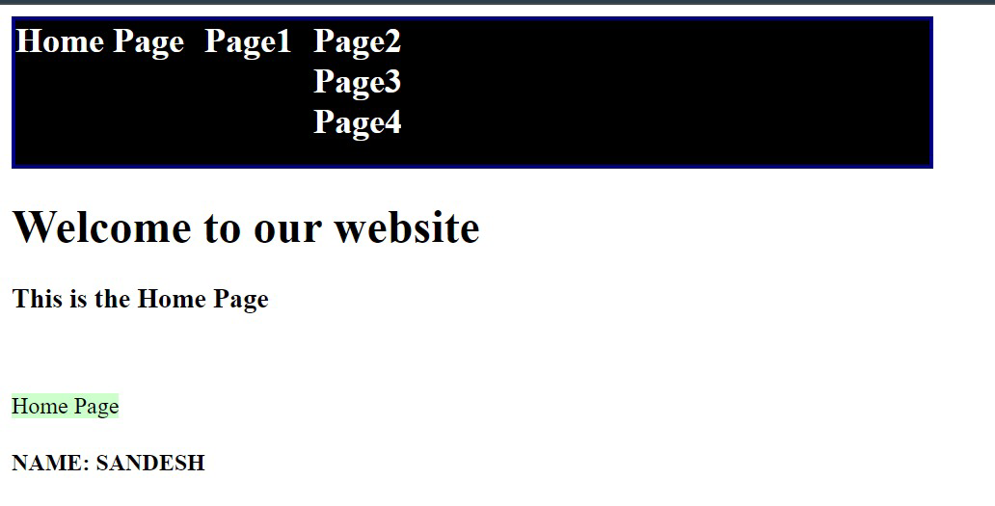

**Practical 5b**

**Aim:** Create a web application to demonstrate use of Master Page and content page

**Design:**

<%@ Page Title="" Language="C#" MasterPageFile="~/Site1.Master" AutoEventWireup="true" CodeBehind="Pract5b.aspx.cs" Inherits="Pract5.Pract5b" Theme ="Theme1"%>

<asp:Content ID="Content1" ContentPlaceHolderID="head" runat="server">

<style type="text/css">

.auto-style1 {

height: 29px;

}

</style>

</asp:Content>

<asp:Content ID="Content2" ContentPlaceHolderID="ContentPlaceHolder1" runat="server">

<h2 align="center"> Contact Us</h2>

<h3 align="center"> Fill the datails</h3>

<table class="auto-style1" align="center">

<tr>

<td class="auto-style1">

<asp:Label ID="Label1" runat="server" Text="Name:"></asp:Label>

</td>

<td class="auto-style1">

<asp:TextBox ID="TextBox1" runat="server" SkinID="Yellow"></asp:TextBox>

</td>

</tr>

<tr>

<td>

<asp:Label ID="Label2" runat="server" Text="Email ID:"></asp:Label>

</td>

<td>

<asp:TextBox ID="TextBox2" runat="server" SkinID="Yellow"></asp:TextBox>

</td>

</tr>

<tr>

<td class="auto-style1">

<asp:Label ID="Label3" runat="server" Text="Mobile No."></asp:Label>

</td>

<td class="auto-style1">

<asp:TextBox ID="TextBox3" runat="server" SkinID="Blue"></asp:TextBox>

</td>

</tr>

<tr>

<td>

<asp:Label ID="Label4" runat="server" Text="Your Query"></asp:Label>

</td>

<td>

<asp:TextBox ID="TextBox4" runat="server" SkinID="Blue"></asp:TextBox>

</td>

</tr>

<tr>

<td>&nbsp;</td>

<td>&nbsp;</td>

</tr>

<tr>

<td colspan="2">

<asp:Button ID="Button1" runat="server" Text="Submit" SkinID="Green" />

</td>

</tr>

</table>

&nbsp;<br />

</asp:Content>

**MasterPage:**

<%@ Master Language="C#" AutoEventWireup="true" CodeBehind="Site1.master.cs" Inherits="Pract5.Site1" %>

<!DOCTYPE html>

<html>

<head runat="server">

<title></title>

<style type="text/css">

body{

background-color:powderblue;

}

.head {

background-color:#cc3399;

color:white;

}

footer{

background-color:black;

color:white;

}

</style>

<asp:ContentPlaceHolder ID="head" runat="server">

</asp:ContentPlaceHolder>

</head>

<body>

<form id="form1" runat="server">

<div class ="head">

<h2 align="center">Ghanshyamdas Jalan College of Science & Commerce</h2>

<h4 align="center"> Chinchowli Rd, Malad, Upper Govind Nagar, Malad East, Mumbai, Maharashtra 400097</h4>

<p align="center"> &nbsp;</p>

</div>

<div>

<asp:ContentPlaceHolder ID="ContentPlaceHolder1" runat="server">

</asp:ContentPlaceHolder>

</div>

<footer align="center">Copyright by GD JALAN</footer>

</form>

<h4>NAME: SANDESH</h4>

</body>

</html>

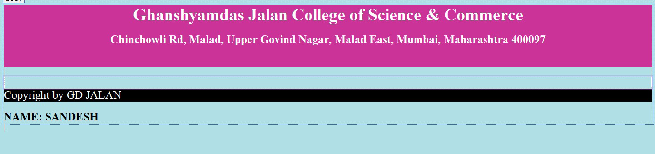

**Output:**

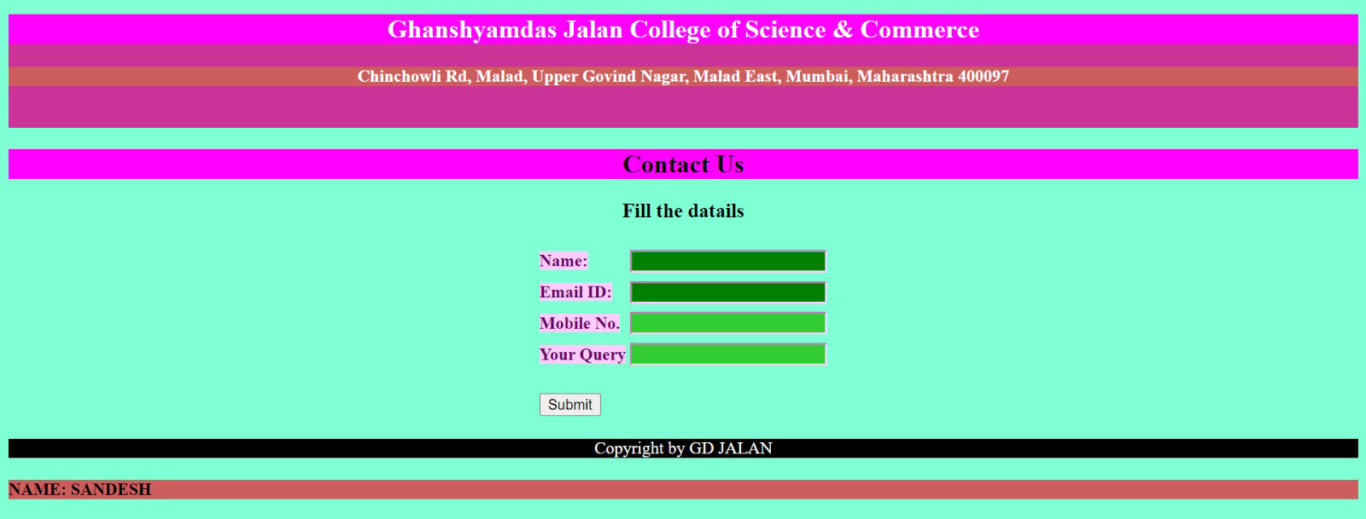

**Practical 5c**

**Aim:** Create a web application to demonstrate various states of ASP.NET Pages.

1. **ViewState:**

**Design:**

<%@ Page Language="C#" AutoEventWireup="true" CodeBehind="Pract 5 C ViewState.aspx.cs" Inherits="Pract5.Pract_5_C_ViewState" %>

<!DOCTYPE html>

<html xmlns="http://www.w3.org/1999/xhtml">

<head runat="server">

<title></title>

</head>

<body>

<form id="form1" runat="server">

<div>

View Variable:

<asp:Label ID="Label1" runat="server" Text="View Data is:"></asp:Label>

<br />

<br />

Session Variable:

<asp:Label ID="Label2" runat="server" Text="Session Variable"></asp:Label>

<br />

<br />

Application Variable:

<asp:Label ID="Label3" runat="server" Text="Application Variable"></asp:Label>

<br />

<br />

<asp:Button ID="Button1" runat="server" OnClick="Button1_Click" Text="Get Data" />

</div>

</form>

<h4>NAME: SANDESH</h4>

</body>

</html>

**Code:**

using System;

using System.Collections.Generic;

using System.Linq;

using System.Web;

using System.Web.UI;

using System.Web.UI.WebControls;

namespace Pract5

{

public partial class Pract_5_C_ViewState : System.Web.UI.Page

{

int count = 0;

protected void Page_Load(object sender, EventArgs e)

{

if (!IsPostBack)

{

if (ViewState["cnt"] == null)

{

//ViewState["cnt"] = count;

ViewState.Add("cnt", count);

}

if (Session["scnt"] == null)

{

//Session["scnt"] = count;

Session.Add("scnt", count);

}

if (Application["acnt"] == null)

{

//Application["acnt"] = count;

Application.Add("acnt", count);

}

}

}

protected void Button1_Click(object sender, EventArgs e)

{

/* count = int.Parse(ViewState["cnt"].ToString());

count++;

ViewState["cnt"] = count;

Label1.Text = ViewState["cnt"].ToString();*/

ViewState["cnt"] = (int)ViewState["cnt"] + 1;

Label1.Text = ViewState["cnt"].ToString();

Session["scnt"] = (int)Session["scnt"] + 1;

Label2.Text = Session["scnt"].ToString();

Application["acnt"] = (int)Application["acnt"] + 1;

Label3.Text = Application["acnt"].ToString();

/*count++;

Label1.Text = count.ToString();*/

}

}

}

**Output:**

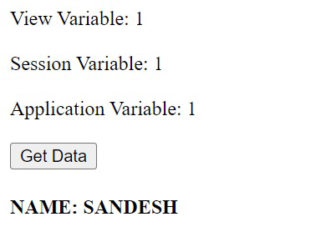

1. **QueryString**

**Design:**

<%@ Page Language="C#" AutoEventWireup="true" CodeBehind="Pract 5c Querystr1.aspx.cs" Inherits="Pract5.Pract_5c_Querystr1" %>

<!DOCTYPE html>

<html xmlns="http://www.w3.org/1999/xhtml">

<head runat="server">

<title></title>

<style type="text/css">

.auto-style1 {

width: 68%;

height: 158px;

}

.auto-style2 {

text-align: center;

}

</style>

</head>

<body>

<form id="form1" runat="server">

<div>

<table class="auto-style1">

<tr>

<td colspan="2"> <h2 align ="center"> Query String Example </h2> &nbsp;</td>

</tr>

<tr>

<td>

<asp:Label ID="Label1" runat="server" Text="UserID"></asp:Label>

</td>

<td>

<asp:TextBox ID="TextBox1" runat="server"></asp:TextBox>

</td>

</tr>

<tr>

<td>

<asp:Label ID="Label2" runat="server" Text="UserName"></asp:Label>

</td>

<td>

<asp:TextBox ID="TextBox2" runat="server"></asp:TextBox>

</td>

</tr>

<tr>

<td class="auto-style2" colspan="2">

<asp:Button ID="Button1" runat="server" OnClick="Button1_Click" Text="Send Data" />

</td>

</tr>

</table>

</div>

</form>

<h4>NAME: SANDESH</h4>

</body>

</html>

**Code:**

using System;

using System.Collections.Generic;

using System.Linq;

using System.Web;

using System.Web.UI;

using System.Web.UI.WebControls;

namespace Pract5

{

public partial class Pract_5c_Querystr1 : System.Web.UI.Page

{

protected void Page_Load(object sender, EventArgs e)

{

}

protected void Button1_Click(object sender, EventArgs e)

{

/*Session["userId"] = TextBox1.Text;

Session["userName"] = TextBox2.Text;*/

/*Application["userId"] = TextBox1.Text;

Application["userName"] = TextBox2.Text;*/

//Response.Redirect("~/Pract 5c Querystr2aspx.aspx");

Response.Redirect("~/Pract 5c Querystr2aspx.aspx?userId=" +TextBox1.Text + "&userName=" + TextBox2.Text );

}

}

}

**Output:**

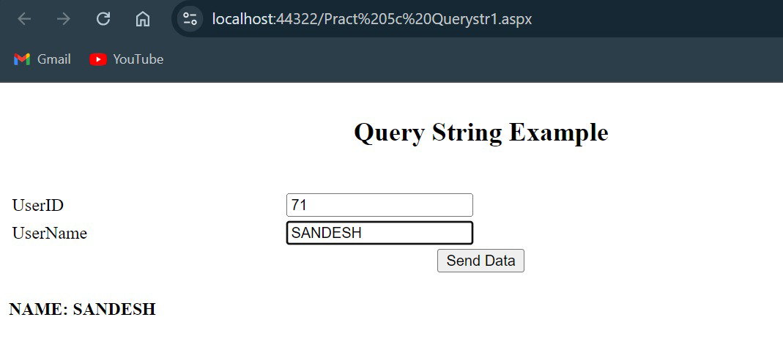

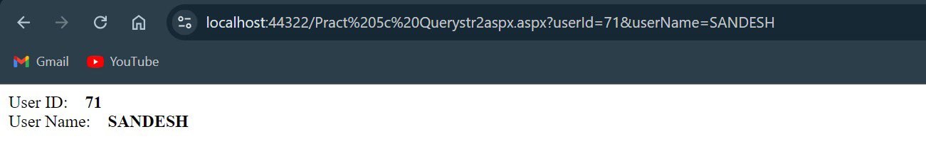

1. **Session and Application State**

**Design:**

<%@ Page Language="C#" AutoEventWireup="true" CodeBehind="Pract 5c Session and Application State.aspx.cs" Inherits="Pract5.Pract_5c_Session_and_Application_State"%>

<!DOCTYPE html>

<html xmlns="http://www.w3.org/1999/xhtml">

<head runat="server">

<title></title>

</head>

<body>

<form id="form1" runat="server">

<div>

<asp:Label ID="Label1" runat="server"></asp:Label>

<br />

<br />

<asp:Button ID="Button1" runat="server" OnClick="Button1_Click" Text="Get Data" />

</div>

</form>

<h4>NAME: SANDESH</h4>

</body>

</html>

**Code:**

using System;

using System.Collections.Generic;

using System.Linq;

using System.Web;

using System.Web.UI;

using System.Web.UI.WebControls;

namespace Pract5

{

public partial class Pract_5c_Session_and_Application_State : System.Web.UI.Page

{

protected void Page_Load(object sender, EventArgs e)

{

}

protected void Button1_Click(object sender, EventArgs e)

{

Label1.Text = "";

Application["OnlineApplicationUsers"] = (int)Application["OnlineApplicationUsers"] + 1;

Label1.Text = "Aplication Count " + Application["OnlineApplicationUsers"];

Session["OnlineSessionUsers"] = (int)Session["OnlineSessionUsers"] + 1;

Label1.Text = Label1.Text + "<br> Session Count " + Session["OnlineSessionUsers"];

}

}

}

**Output:**

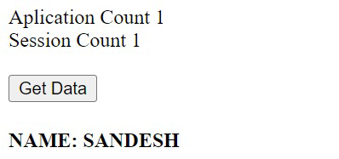

1. **Cookies**

**Design:**

<%@ Page Language="C#" AutoEventWireup="true" CodeBehind="Practica5cCookies1.aspx.cs" Inherits="Pract5.Practica5cCookies1" %>

<!DOCTYPE html>

<html xmlns="http://www.w3.org/1999/xhtml">

<head runat="server">

<title></title>

</head>

<body>

<form id="form1" runat="server">

<div>

<asp:Label ID="Label1" runat="server" Text="UserName:"></asp:Label>

&nbsp;&nbsp;&nbsp;

<asp:TextBox ID="TextBox1" runat="server"></asp:TextBox>

<br />

User Email:&nbsp;&nbsp;

<asp:TextBox ID="TextBox2" runat="server"></asp:TextBox>

<br />

<br />

<asp:Button ID="Button1" runat="server" OnClick="Button1_Click" Text="Submit" />

</div>

</form>

<h4>NAME: SANDESH</h4>

</body>

</html>

**Code:**

using System;

using System.Collections.Generic;

using System.Linq;

using System.Web;

using System.Web.UI;

using System.Web.UI.WebControls;

namespace Pract5

{

public partial class Practica5cCookies1 : System.Web.UI.Page

{

protected void Page_Load(object sender, EventArgs e)

{

}

protected void Button1_Click(object sender, EventArgs e)

{

HttpCookie cookie = new HttpCookie("UserInfo");

cookie["Name"] = TextBox1.Text;

cookie["Email"] = TextBox2.Text;

cookie.Expires = DateTime.Now.AddDays(3);

//cookie.Expires = DateTime.Now.AddSeconds(100);

Response.Cookies.Add(cookie);

Response.Redirect("~/Practica5cCookies2.aspx");

}

}

}

**Output:**

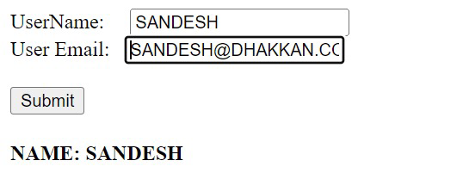

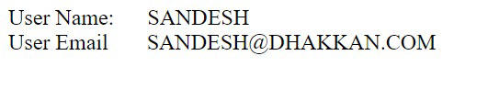

**Practical 6a**

**Aim:** Create a web application for inserting and deleting records from a database.

**Design & Code:**

<%@ Page Language="C#" AutoEventWireup="true" CodeBehind="WebForm1.aspx.cs" Inherits="New_Pract_6a.WebForm1" %>

<!DOCTYPE html>

<html xmlns="http://www.w3.org/1999/xhtml">

<head runat="server">

<title></title>

</head>

<body>

<form id="form1" runat="server">

<div>

<h2>Inserting and deleting records from a database</h2>

<asp:DetailsView ID="DetailsView1" runat="server" Height="54px" Width="157px" AllowPaging="True" AutoGenerateRows="False" BackColor="#DEBA84" BorderColor="#DEBA84" BorderStyle="None" BorderWidth="1px" CellPadding="3" CellSpacing="2" DataKeyNames="Cust_Id" DataSourceID="SqlDataSource1">

<EditRowStyle BackColor="#738A9C" Font-Bold="True" ForeColor="White" />

<Fields>

<asp:BoundField DataField="Cust_Id" HeaderText="Cust_Id" ReadOnly="True" SortExpression="Cust_Id" />

<asp:BoundField DataField="Cust_Name" HeaderText="Cust_Name" SortExpression="Cust_Name" />

<asp:BoundField DataField="State" HeaderText="State" SortExpression="State" />

<asp:BoundField DataField="City" HeaderText="City" SortExpression="City" />

<asp:CommandField ShowDeleteButton="True" ShowInsertButton="True" />

</Fields>

<FooterStyle BackColor="#F7DFB5" ForeColor="#8C4510" />

<FooterTemplate>

Copyright by Ravi Sir

</FooterTemplate>

<HeaderStyle BackColor="#A55129" Font-Bold="True" ForeColor="White" />

<HeaderTemplate>

Customer Details:

</HeaderTemplate>

<PagerStyle ForeColor="#8C4510" HorizontalAlign="Center" />

<RowStyle BackColor="#FFF7E7" ForeColor="#8C4510" />

</asp:DetailsView>

<asp:SqlDataSource ID="SqlDataSource1" runat="server" ConflictDetection="CompareAllValues" ConnectionString="<%$ ConnectionStrings:TYConnectionString %>" DeleteCommand="DELETE FROM [Customer] WHERE [Cust_Id] = @original_Cust_Id AND (([Cust_Name] = @original_Cust_Name) OR ([Cust_Name] IS NULL AND @original_Cust_Name IS NULL)) AND (([State] = @original_State) OR ([State] IS NULL AND @original_State IS NULL)) AND (([City] = @original_City) OR ([City] IS NULL AND @original_City IS NULL))" InsertCommand="INSERT INTO [Customer] ([Cust_Id], [Cust_Name], [State], [City]) VALUES (@Cust_Id, @Cust_Name, @State, @City)" OldValuesParameterFormatString="original_{0}" SelectCommand="SELECT * FROM [Customer]" UpdateCommand="UPDATE [Customer] SET [Cust_Name] = @Cust_Name, [State] = @State, [City] = @City WHERE [Cust_Id] = @original_Cust_Id AND (([Cust_Name] = @original_Cust_Name) OR ([Cust_Name] IS NULL AND @original_Cust_Name IS NULL)) AND (([State] = @original_State) OR ([State] IS NULL AND @original_State IS NULL)) AND (([City] = @original_City) OR ([City] IS NULL AND @original_City IS NULL))">

<DeleteParameters>

<asp:Parameter Name="original_Cust_Id" Type="Int32" />

<asp:Parameter Name="original_Cust_Name" Type="String" />

<asp:Parameter Name="original_State" Type="String" />

<asp:Parameter Name="original_City" Type="String" />

</DeleteParameters>

<InsertParameters>

<asp:Parameter Name="Cust_Id" Type="Int32" />

<asp:Parameter Name="Cust_Name" Type="String" />

<asp:Parameter Name="State" Type="String" />

<asp:Parameter Name="City" Type="String" />

</InsertParameters>

<UpdateParameters>

<asp:Parameter Name="Cust_Name" Type="String" />

<asp:Parameter Name="State" Type="String" />

<asp:Parameter Name="City" Type="String" />

<asp:Parameter Name="original_Cust_Id" Type="Int32" />

<asp:Parameter Name="original_Cust_Name" Type="String" />

<asp:Parameter Name="original_State" Type="String" />

<asp:Parameter Name="original_City" Type="String" />

</UpdateParameters>

</asp:SqlDataSource>

<br />

<br />

<asp:FormView ID="FormView1" runat="server" BackColor="#DEBA84" BorderColor="#DEBA84" BorderStyle="None" BorderWidth="1px" CellPadding="3" CellSpacing="2" DataKeyNames="Cust_Id" DataSourceID="SqlDataSource1" GridLines="Both">

<EditItemTemplate>

Cust_Id:

<asp:Label ID="Cust_IdLabel1" runat="server" Text='<%# Bind("Cust_Id") %>' />

<br />

Cust_Name:

<asp:TextBox ID="Cust_NameTextBox" runat="server" Text='<%# Bind("Cust_Name") %>' />

<br />

State:

<asp:TextBox ID="StateTextBox" runat="server" Text='<%# Bind("State") %>' />

<br />

City:

<asp:TextBox ID="CityTextBox" runat="server" Text='<%# Bind("City") %>' />

<br />

<asp:LinkButton ID="UpdateButton" runat="server" CausesValidation="True" CommandName="Update" Text="Update" />

&nbsp;<asp:LinkButton ID="UpdateCancelButton" runat="server" CausesValidation="False" CommandName="Cancel" Text="Cancel" />

</EditItemTemplate>

<EditRowStyle BackColor="#738A9C" Font-Bold="True" ForeColor="White" />

<FooterStyle BackColor="#F7DFB5" ForeColor="#8C4510" />

<FooterTemplate>

Copyright by Ravi Sir

</FooterTemplate>

<HeaderStyle BackColor="#A55129" Font-Bold="True" ForeColor="White" />

<HeaderTemplate>

Customer Details:

</HeaderTemplate>

<InsertItemTemplate>

Cust_Id:

<asp:TextBox ID="Cust_IdTextBox" runat="server" Text='<%# Bind("Cust_Id") %>' />

<br />

Cust_Name:

<asp:TextBox ID="Cust_NameTextBox" runat="server" Text='<%# Bind("Cust_Name") %>' />

<br />

State:

<asp:TextBox ID="StateTextBox" runat="server" Text='<%# Bind("State") %>' />

<br />

City:

<asp:TextBox ID="CityTextBox" runat="server" Text='<%# Bind("City") %>' />

<br />

<asp:LinkButton ID="InsertButton" runat="server" CausesValidation="True" CommandName="Insert" Text="Insert" />

&nbsp;<asp:LinkButton ID="InsertCancelButton" runat="server" CausesValidation="False" CommandName="Cancel" Text="Cancel" />

</InsertItemTemplate>

<ItemTemplate>

Cust_Id:

<asp:Label ID="Cust_IdLabel" runat="server" Text='<%# Bind("Cust_Id") %>' />

<br />

Cust_Name:

<asp:Label ID="Cust_NameLabel" runat="server" Text='<%# Bind("Cust_Name") %>' />

<br />

State:

<asp:Label ID="StateLabel" runat="server" Text='<%# Bind("State") %>' />

<br />

City:

<asp:Label ID="CityLabel" runat="server" Text='<%# Bind("City") %>' />

<br />

<asp:LinkButton ID="EditButton" runat="server" CausesValidation="False" CommandName="Edit" Text="Edit" />

&nbsp;<asp:LinkButton ID="DeleteButton" runat="server" CausesValidation="False" CommandName="Delete" Text="Delete" />

&nbsp;<asp:LinkButton ID="NewButton" runat="server" CausesValidation="False" CommandName="New" Text="New" />

</ItemTemplate>

<PagerStyle ForeColor="#8C4510" HorizontalAlign="Center" />

<RowStyle BackColor="#FFF7E7" ForeColor="#8C4510" />

</asp:FormView>

<br />

<h4>NAME: SANDESH</h4>

</div>

</form>

</body>

</html>

**Web.config:**

<?xml version="1.0" encoding="utf-8"?>

<!--

For more information on how to configure your ASP.NET application, please visit

https://go.microsoft.com/fwlink/?LinkId=169433

-->

<configuration>

<connectionStrings>

<add name="TYConnectionString" connectionString="Server=SAKET;Database=TYDatabase;Integrated Security=True;" providerName="System.Data.SqlClient" />

</connectionStrings>

<system.web>

<compilation debug="true" targetFramework="4.7.2" />

<httpRuntime targetFramework="4.7.2" />

</system.web>

<system.codedom>

<compilers>

<compiler language="c#;cs;csharp" extension=".cs" warningLevel="4" compilerOptions="/langversion:default /nowarn:1659;1699;1701;612;618" type="Microsoft.CodeDom.Providers.DotNetCompilerPlatform.CSharpCodeProvider, Microsoft.CodeDom.Providers.DotNetCompilerPlatform, Version=4.1.0.0, Culture=neutral, PublicKeyToken=31bf3856ad364e35" />

<compiler language="vb;vbs;visualbasic;vbscript" extension=".vb" warningLevel="4" compilerOptions="/langversion:default /nowarn:41008,40000,40008 /define:_MYTYPE=\&quot;Web\&quot; /optionInfer+" type="Microsoft.CodeDom.Providers.DotNetCompilerPlatform.VBCodeProvider, Microsoft.CodeDom.Providers.DotNetCompilerPlatform, Version=4.1.0.0, Culture=neutral, PublicKeyToken=31bf3856ad364e35" />

</compilers>

</system.codedom>

</configuration>

**Output:**

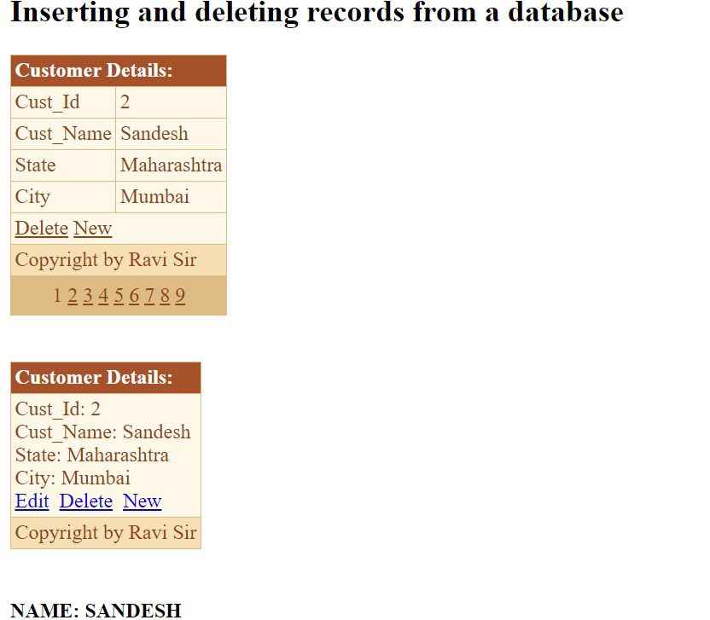



**Practical 6b**

**Aim:** Create a web application to display Using Disconnected Data Access and Databinding using GridView

**Design:**

<%@ Page Language="C#" AutoEventWireup="true" CodeBehind="Pract 6b.aspx.cs" Inherits="Practical_8.Pract_8c" %>

<!DOCTYPE html>

<html xmlns="http://www.w3.org/1999/xhtml">

<head runat="server">

<title></title>

</head>

<body>

<form id="form1" runat="server">

<div>

<asp:Label ID="Label1" runat="server" Text="Employee Salary &gt;"></asp:Label>

&nbsp;<asp:TextBox ID="TextBox1" runat="server"></asp:TextBox>

&nbsp;

<asp:Button ID="Button1" runat="server" OnClick="Button1_Click" Text="Button" />

<br />

<br />

<asp:Label ID="Label2" runat="server"></asp:Label>

<br />

<br />

<asp:GridView ID="GridView1" runat="server" BorderStyle="Ridge" CellPadding="4" ForeColor="#333333" GridLines="None">

<AlternatingRowStyle BackColor="White" ForeColor="#284775" />

<EditRowStyle BackColor="#999999" />

<FooterStyle BackColor="#5D7B9D" Font-Bold="True" ForeColor="White" />

<HeaderStyle BackColor="#5D7B9D" Font-Bold="True" ForeColor="White" />

<PagerStyle BackColor="#284775" ForeColor="White" HorizontalAlign="Center" />

<RowStyle BackColor="#F7F6F3" ForeColor="#333333" />

<SelectedRowStyle BackColor="#E2DED6" Font-Bold="True" ForeColor="#333333" />

<SortedAscendingCellStyle BackColor="#E9E7E2" />

<SortedAscendingHeaderStyle BackColor="#506C8C" />

<SortedDescendingCellStyle BackColor="#FFFDF8" />

<SortedDescendingHeaderStyle BackColor="#6F8DAE" />

</asp:GridView>

</div>

</form>

<h4>NAME: SANDESH</h4>

</body>

</html>

**Code:**

using System;

using System.Collections.Generic;

using System.Linq;

using System.Web;

using System.Web.UI;

using System.Web.UI.WebControls;

using System.Data;

using System.Data.SqlClient;

using System.Web.Configuration;

using System.Configuration;

namespace Practical_8

{

public partial class Pract_8c : System.Web.UI.Page

{

protected void Page_Load(object sender, EventArgs e)

{

}

protected void Button1_Click(object sender, EventArgs e)

{

try

{

// Debugging - Check if TextBox1 is null

if (TextBox1 == null)

{

throw new Exception("TextBox1 is null.");

}

string connStr = WebConfigurationManager.ConnectionStrings["connStr"].ConnectionString;

if (string.IsNullOrEmpty(connStr))

{

Label2.Text = "Connection string not found!";

return;

}

using (SqlConnection con = new SqlConnection(connStr))

{

con.Open();

string sql = "SELECT * FROM Employee WHERE Esalary > @Salary";

using (SqlCommand cmd = new SqlCommand(sql, con))

{

decimal salary;

if (decimal.TryParse(TextBox1.Text, out salary))

{

cmd.Parameters.AddWithValue("@Salary", salary);

SqlDataAdapter da = new SqlDataAdapter(cmd);

DataSet ds = new DataSet();

da.Fill(ds);

// Debugging - Check if dataset is empty

if (ds.Tables.Count == 0 || ds.Tables[0].Rows.Count == 0)

{

Label2.Text = "No records found.";

}

else

{

GridView1.DataSource = ds.Tables[0];

GridView1.DataBind();

}

}

else

{

Label2.Text = "Please enter a valid salary.";

}

}

}

}

catch (Exception ex)

{

Label2.Text = "";

Label2.Text = "Invalid Query ..." + ex.Message;

}

}

}

}

**Web.config:**

<?xml version="1.0" encoding="utf-8"?>

<!--

For more information on how to configure your ASP.NET application, please visit

https://go.microsoft.com/fwlink/?LinkId=169433

-->

<configuration>

<system.web>

<compilation debug="true" targetFramework="4.7.2" />

<httpRuntime targetFramework="4.7.2" />

</system.web>

<connectionStrings>

<add name="connStr" connectionString="Data Source=SAKET;Initial Catalog=EmployeeDB;Integrated Security=True" providerName="System.Data.SqlClient" />

</connectionStrings>

</configuration>

**Output:**

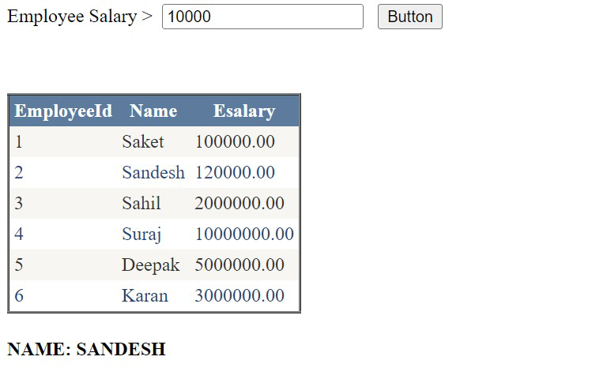

**Practical 7a**

**Aim:** Create a web application to demonstrate the use of different types of Cookies.

**Design:**

<%@ Page Language="C#" AutoEventWireup="true" CodeBehind="CookiesDemo.aspx.cs" Inherits="New_Pract_7a.CookiesDemo" %>

<!DOCTYPE html>

<html xmlns="http://www.w3.org/1999/xhtml">

<head runat="server">

<meta charset="utf-8" />

<title>Cookie Demo</title>

</head>

<body>

<form id="form1" runat="server">

<div>

<h2>Cookie Demonstration</h2>

<asp:Label ID="lblMessage" runat="server" Text="Cookie Info will appear here." />

<h3>Create Cookies</h3>

<label for="cookieValue">Enter Cookie Value:</label>

<asp:TextBox ID="txtCookieValue" runat="server"></asp:TextBox>

<br /><br />

<asp:Button ID="btnCreateSessionCookie" runat="server" Text="Create Session Cookie" OnClick="btnCreateSessionCookie_Click" />

<asp:Button ID="btnCreatePersistentCookie" runat="server" Text="Create Persistent Cookie" OnClick="btnCreatePersistentCookie_Click" />

<asp:Button ID="btnCreateSecureCookie" runat="server" Text="Create Secure Cookie" OnClick="btnCreateSecureCookie_Click" />

<br /><br />

<h3>Retrieve Cookie</h3>

<asp:Button ID="btnRetrieveCookie" runat="server" Text="Retrieve Cookie" OnClick="btnRetrieveCookie_Click" />

<br /><br />

<h3>Delete Cookie</h3>

<asp:Button ID="btnDeleteCookie" runat="server" Text="Delete Cookie" OnClick="btnDeleteCookie_Click" />

</div>

</form>

<h4>NAME: SANDESH</h4>

</body>

</html>

**Code:**

using System;

using System.Collections.Generic;

using System.Linq;

using System.Web;

using System.Web.UI;

using System.Web.UI.WebControls;

namespace New_Pract_7a

{

public partial class CookiesDemo : System.Web.UI.Page

{

protected void Page_Load(object sender, EventArgs e)

{

lblMessage.Text = "";

}

// Create a session cookie (expires when browser is closed)

protected void btnCreateSessionCookie_Click(object sender, EventArgs e)

{

string cookieValue = txtCookieValue.Text;

HttpCookie sessionCookie = new HttpCookie("SessionCookie", cookieValue);

Response.Cookies.Add(sessionCookie);

lblMessage.Text = "Session Cookie created successfully.";

}

// Create a persistent cookie (expires in 30 days)

protected void btnCreatePersistentCookie_Click(object sender, EventArgs e)

{

string cookieValue = txtCookieValue.Text;

HttpCookie persistentCookie = new HttpCookie("PersistentCookie", cookieValue);

persistentCookie.Expires = DateTime.Now.AddDays(30); // Set expiration to 30 days

Response.Cookies.Add(persistentCookie);

lblMessage.Text = "Persistent Cookie created successfully.";

}

// Create a secure cookie (only sent over HTTPS)

protected void btnCreateSecureCookie_Click(object sender, EventArgs e)

{

string cookieValue = txtCookieValue.Text;

HttpCookie secureCookie = new HttpCookie("SecureCookie", cookieValue);

secureCookie.Secure = true; // Ensure it's sent only over HTTPS

Response.Cookies.Add(secureCookie);

lblMessage.Text = "Secure Cookie created successfully.";

}

// Retrieve cookie value

protected void btnRetrieveCookie_Click(object sender, EventArgs e)

{

if (Request.Cookies["SessionCookie"] != null)

{

lblMessage.Text = "Session Cookie: " + Request.Cookies["SessionCookie"].Value + "<br/>";

}

if (Request.Cookies["PersistentCookie"] != null)

{

lblMessage.Text += "Persistent Cookie: " + Request.Cookies["PersistentCookie"].Value + "<br/>";

}

if (Request.Cookies["SecureCookie"] != null)

{

lblMessage.Text += "Secure Cookie: " + Request.Cookies["SecureCookie"].Value + "<br/>";

}

if (lblMessage.Text == "")

{

lblMessage.Text = "No cookies found.";

}

}

// Delete cookie

protected void btnDeleteCookie_Click(object sender, EventArgs e)

{

if (Request.Cookies["SessionCookie"] != null)

{

HttpCookie sessionCookie = new HttpCookie("SessionCookie");

sessionCookie.Expires = DateTime.Now.AddDays(-1); // Expire the cookie

Response.Cookies.Add(sessionCookie);

}

if (Request.Cookies["PersistentCookie"] != null)

{

HttpCookie persistentCookie = new HttpCookie("PersistentCookie");

persistentCookie.Expires = DateTime.Now.AddDays(-1); // Expire the cookie

Response.Cookies.Add(persistentCookie);

}

if (Request.Cookies["SecureCookie"] != null)

{

HttpCookie secureCookie = new HttpCookie("SecureCookie");

secureCookie.Expires = DateTime.Now.AddDays(-1); // Expire the cookie

Response.Cookies.Add(secureCookie);

}

lblMessage.Text = "All cookies have been deleted.";

}

}

}

**Output:**

**Session Cookie creation:**

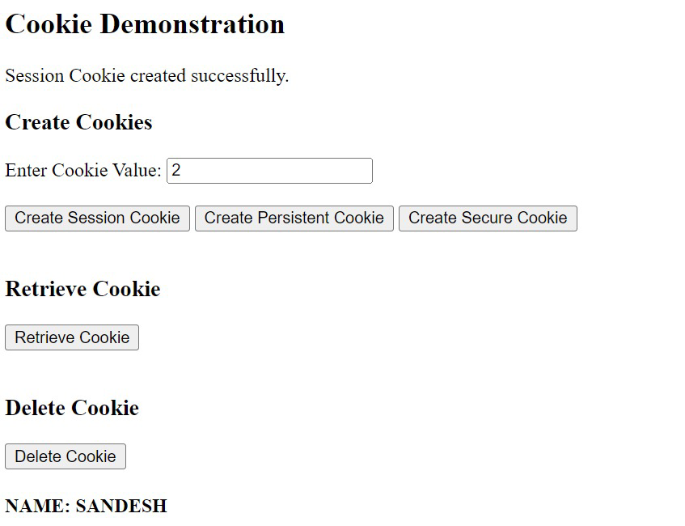

**Persistent Cookie creation:**

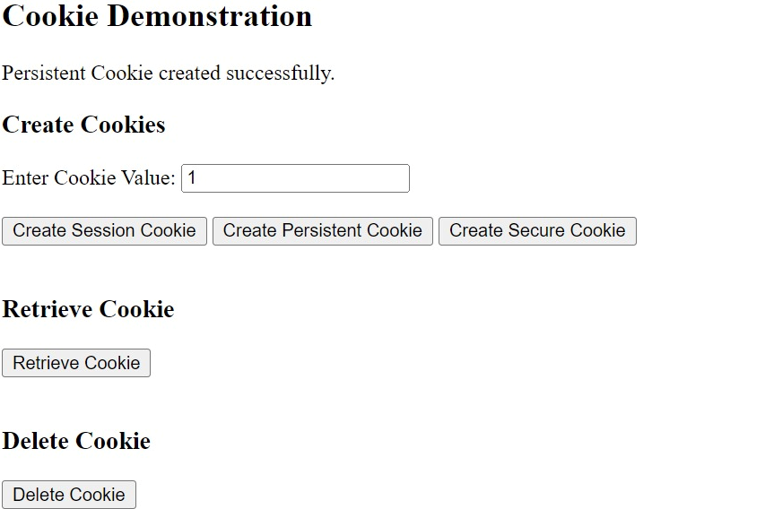

**Secure Cookie creation:**

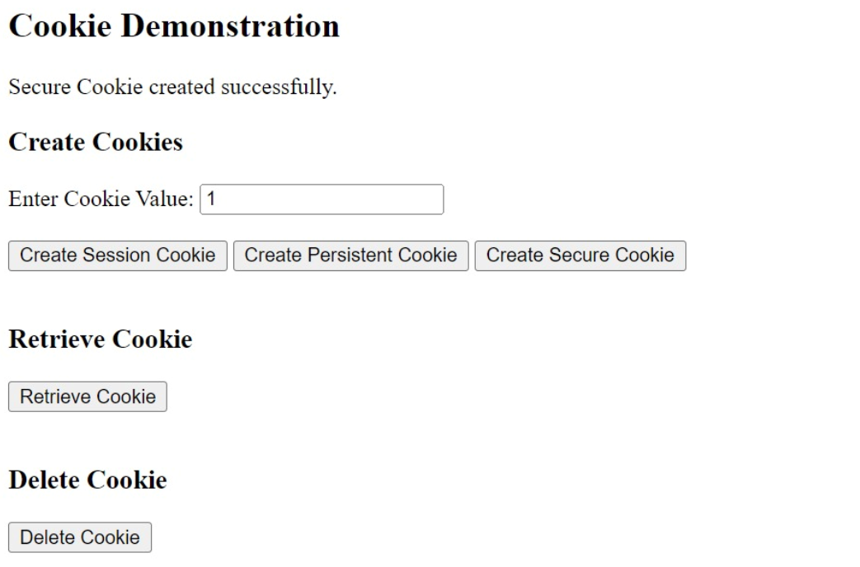

**Retrieving Cookie:**

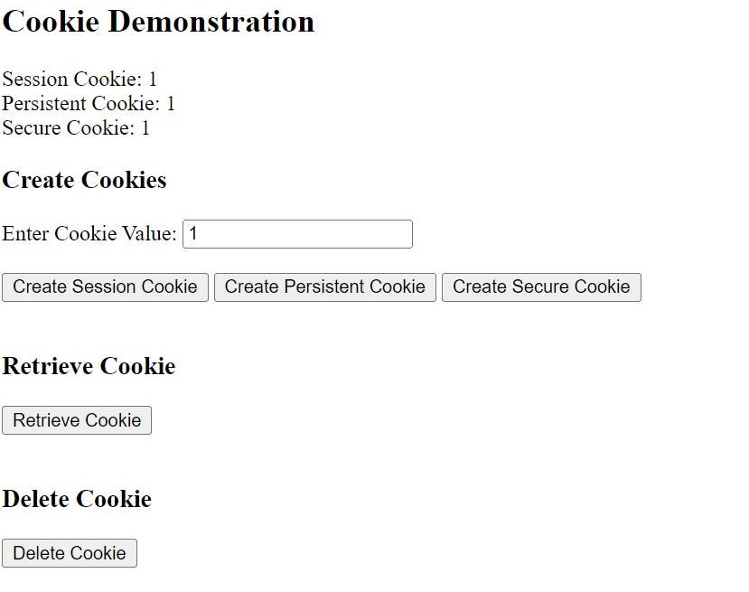

**Deleting Cookie:**

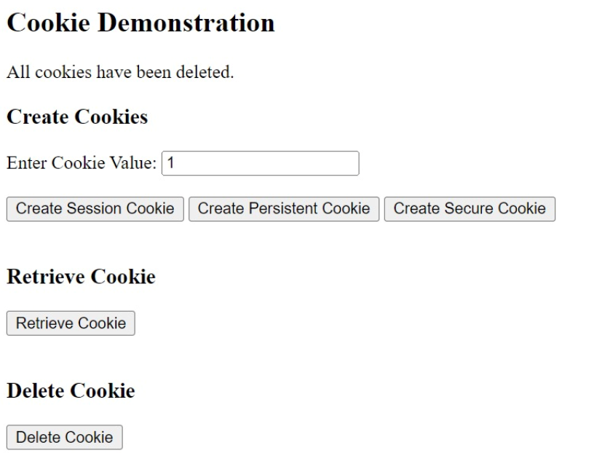

**Practical 7b**

**Aim:** Create a web application to demonstrate Form Security and Windows Security with proper Authentication and Authorization properties.

**Design:**

**Code:**

**Output:**

**Practical 8a**

**Aim:** Create a web application for inserting and deleting records from a database. (Using ExecuteNon Query).

**Design:**

<%@ Page Language="C#" AutoEventWireup="true" CodeBehind="Pract 8a.aspx.cs" Inherits="Practical_8.Pract_8a" %>

<!DOCTYPE html>

<html xmlns="http://www.w3.org/1999/xhtml">

<head runat="server">

<title></title>

<style type="text/css">

.auto-style1 {

width: 36%;

height: 111px;

}

</style>

</head>

<body>

<form id="form1" runat="server">

<div>

<table class="auto-style1">

<tr>

<td>

<asp:Label ID="Label2" runat="server" Text="Employee ID"></asp:Label>

</td>

<td>

<asp:TextBox ID="TextBox1" runat="server"></asp:TextBox>

</td>

</tr>

<tr>

<td>

<asp:Label ID="Label3" runat="server" Text="Employee Name"></asp:Label>

</td>

<td>

<asp:TextBox ID="TextBox2" runat="server"></asp:TextBox>

</td>

</tr>

<tr>

<td>

<asp:Label ID="Label4" runat="server" Text="Employee Salary"></asp:Label>

</td>

<td>

<asp:TextBox ID="TextBox3" runat="server"></asp:TextBox>

</td>

</tr>

<tr>

<td>&nbsp;</td>

<td>&nbsp;</td>

</tr>

<tr>

<td>

<asp:Button ID="Button1" runat="server" Text="Insert" OnClick="Button1_Click" />

</td>

<td>&nbsp;</td>

</tr>

<tr>

<td colspan="2">

<asp:Label ID="Label5" runat="server"></asp:Label>

</td>

</tr>

</table>

<asp:SqlDataSource ID="SqlDataSource1" runat="server"

ConnectionString="<%$ ConnectionStrings:connStr2 %>"

InsertCommand="INSERT INTO [Employee2] ([Eid], [Ename], [Esalary]) VALUES (@Eid, @Ename, @Esalary)">

<InsertParameters>

<asp:Parameter Name="Eid" Type="Int32" />

<asp:Parameter Name="Ename" Type="String" />

<asp:Parameter Name="Esalary" Type="Decimal" />

</InsertParameters>

</asp:SqlDataSource>

<br />

<asp:Label ID="Label6" runat="server" Text="Select Employee Id:"></asp:Label>

&nbsp;<asp:DropDownList ID="DropDownList1" runat="server" DataTextField="Eid" DataValueField="Eid">

</asp:DropDownList>

<asp:SqlDataSource ID="SqlDataSource2" runat="server"

ConnectionString="<%$ ConnectionStrings:connStr2 %>"

SelectCommand="SELECT Eid FROM Employee2">

</asp:SqlDataSource>

<br />

<br />

<asp:Button ID="Button2" runat="server" OnClick="Button2_Click" Text="Delete" />

<br />

<br />

</div>

</form>

<h4>NAME: SANDESH</h4>

</body>

</html>

**Code:**

using System;

using System.Web.UI;

using System.Web.UI.WebControls;

namespace Practical_8

{

public partial class Pract_8a : System.Web.UI.Page

{

protected void Page_Load(object sender, EventArgs e)

{

// Optional: Bind the DropDownList on first load

if (!IsPostBack)

{

DropDownList1.DataBind();

}

}

protected void Button1_Click(object sender, EventArgs e)

{

// Validate TextBox inputs

if (string.IsNullOrEmpty(TextBox1.Text) || string.IsNullOrEmpty(TextBox2.Text) || string.IsNullOrEmpty(TextBox3.Text))

{

Label5.Text = "Please fill all fields.";

return;

}

// Set Insert Parameters

SqlDataSource1.InsertParameters["Eid"].DefaultValue = TextBox1.Text;

SqlDataSource1.InsertParameters["Ename"].DefaultValue = TextBox2.Text;

SqlDataSource1.InsertParameters["Esalary"].DefaultValue = TextBox3.Text;

// Execute Insert

try

{

SqlDataSource1.Insert();

Label5.Text = "Record added successfully";

DropDownList1.DataBind(); // Refresh the DropDownList

}

catch (Exception ex)

{

Label5.Text = "Error: " + ex.Message;

}

}

protected void Button2_Click(object sender, EventArgs e)

{

// Validate DropDownList selection

if (DropDownList1.SelectedValue == "")

{

Label5.Text = "Please select an employee to delete.";

return;

}

// Set Delete Command and execute

try

{

SqlDataSource1.DeleteCommand = "DELETE FROM Employee2 WHERE Eid = @Eid";

SqlDataSource1.DeleteParameters.Clear();

SqlDataSource1.DeleteParameters.Add("Eid", DropDownList1.SelectedItem.Value);

SqlDataSource1.Delete();

Label5.Text = "Record deleted successfully";

DropDownList1.DataBind(); // Refresh the DropDownList

}

catch (Exception ex)

{

Label5.Text = "Error: " + ex.Message;

}

}

}

}

**Output:**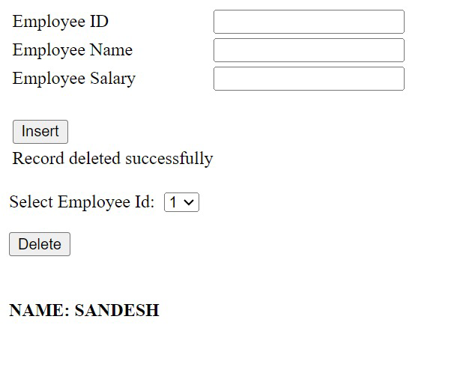

**Practical 8b**

**Aim:** Create a web application for user defined exception handling.

**Design:**

<%@ Page Language="C#" AutoEventWireup="true" CodeBehind="WebForm1.aspx.cs" Inherits="New_Pract_8_b.WebForm1" %>

<!DOCTYPE html>

<html xmlns="http://www.w3.org/1999/xhtml">

<head runat="server">

<title></title>

</head>

<body>

<form id="form1" runat="server">

<div>

<asp:Label ID="Label1" runat="server" Text=""></asp:Label>

<br />

<br />

<asp:Label ID="Label2" runat="server" Text=""></asp:Label>

</div>

</form>

</body>

</html>

**Code:**

using System;

using System.Collections.Generic;

using System.Linq;

using System.Web;

using System.Web.UI;

using System.Web.UI.WebControls;

namespace New_Pract_8_b

{

public partial class WebForm1 : System.Web.UI.Page

{

protected void Page_Load(object sender, EventArgs e)

{

try

{

// Throwing the custom exception

throw new UserDefinedException("New User Defined Exception");

}

catch (UserDefinedException ex) // Catching the custom exception

{

Label1.Text = "<b>Exception caught here: </b>" + ex.Message;

}

catch (Exception ex) // Catching any other exceptions

{

Label1.Text = "<b>Exception caught here: </b>" + ex.ToString();

}

// Final statement

Label2.Text = "Final Statement that is executed";

}

// Custom exception class

class UserDefinedException : Exception

{

public UserDefinedException(string message) : base(message)

{

// Optionally log the exception message or perform other actions

}

}

}

}

**Output:**

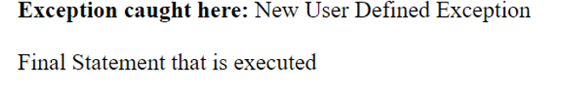

**Practical 9a**

**Aim:** Create a web application to demonstrate use of GridView button column and GridView events along with paging and sorting.

**Design & Code:**

<%@ Page Language="C#" AutoEventWireup="true" CodeBehind="Pract 9 a.aspx.cs" Inherits="Practical_8.Pract_9_a" %>

<!DOCTYPE html>

<html xmlns="http://www.w3.org/1999/xhtml">

<head runat="server">

<title></title>

</head>

<body>

<form id="form1" runat="server">

<div>

<asp:GridView ID="GridView1" runat="server" AllowPaging="True" AutoGenerateColumns="False" CellPadding="4" DataKeyNames="EmployeeId" DataSourceID="SqlDataSource1" ForeColor="#333333" GridLines="None" Height="283px" Width="452px">

<AlternatingRowStyle BackColor="White" ForeColor="#284775" />

<Columns>

<asp:BoundField DataField="EmployeeId" HeaderText="EmployeeId" SortExpression="EmployeeId" InsertVisible="False" ReadOnly="True" />

<asp:BoundField DataField="Name" HeaderText="Name" SortExpression="Name" />

<asp:BoundField DataField="Esalary" HeaderText="Esalary" SortExpression="Esalary" />

</Columns>

<EditRowStyle BackColor="#999999" />

<EmptyDataTemplate>

No Record Found

</EmptyDataTemplate>

<FooterStyle BackColor="#5D7B9D" Font-Bold="True" ForeColor="White" />

<HeaderStyle BackColor="#5D7B9D" Font-Bold="True" ForeColor="White" />

<PagerStyle BackColor="#284775" ForeColor="White" HorizontalAlign="Center" />

<PagerTemplate>

Pager Template

</PagerTemplate>

<RowStyle BackColor="#F7F6F3" ForeColor="#333333" />

<SelectedRowStyle BackColor="#E2DED6" Font-Bold="True" ForeColor="#333333" />

<SortedAscendingCellStyle BackColor="#E9E7E2" />

<SortedAscendingHeaderStyle BackColor="#506C8C" />

<SortedDescendingCellStyle BackColor="#FFFDF8" />

<SortedDescendingHeaderStyle BackColor="#6F8DAE" />

</asp:GridView>

<asp:SqlDataSource ID="SqlDataSource1" runat="server" ConnectionString="<%$ ConnectionStrings:connStr %>" SelectCommand="SELECT * FROM [Employee]"></asp:SqlDataSource>

</div>

</form>

</body>

</html>

**Output:**

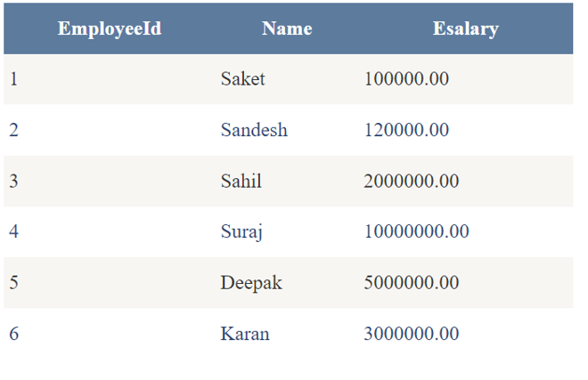

**Practical 9b**

**Aim:** Create a web application to demonstrate data binding using DetailsView and FormView Control

**Design:**

<%@ Page Language="C#" AutoEventWireup="true" CodeBehind="PRACT 9 B.aspx.cs" Inherits="Practical_8.WebForm1" %>

<!DOCTYPE html>

<html xmlns="http://www.w3.org/1999/xhtml">

<head runat="server">

<title></title>

</head>

<body>

<form id="form1" runat="server">

<div>

<!-- DetailsView Control -->

<asp:DetailsView ID="DetailsView1" runat="server" DataSourceID="SqlDataSource1" AutoGenerateRows="False" DataKeyNames="EmployeeId">

<Fields>

<asp:BoundField DataField="EmployeeId" HeaderText="EmployeeId" InsertVisible="False" ReadOnly="True" SortExpression="EmployeeId" />

<asp:BoundField DataField="Name" HeaderText="Name" SortExpression="Name" />

<asp:BoundField DataField="Esalary" HeaderText="Esalary" SortExpression="Esalary" />

</Fields>

</asp:DetailsView>

<br />

<!-- FormView Control -->

<asp:FormView ID="FormView1" runat="server" DataSourceID="SqlDataSource1" DataKeyNames="EmployeeId" OnItemCommand="FormView1_ItemCommand" >

<EditItemTemplate>

EmployeeId:

<asp:Label ID="EmployeeIdLabel1" runat="server" Text='<%# Eval("EmployeeId") %>' />

<br />

Name:

<asp:TextBox ID="NameTextBox" runat="server" Text='<%# Bind("Name") %>' />

<br />

Esalary:

<asp:TextBox ID="EsalaryTextBox" runat="server" Text='<%# Bind("Esalary") %>' />

<br />

<asp:LinkButton ID="UpdateButton" runat="server" CausesValidation="True" CommandName="Update" Text="Update" />

&nbsp;<asp:LinkButton ID="UpdateCancelButton" runat="server" CausesValidation="False" CommandName="Cancel" Text="Cancel" />

</EditItemTemplate>

<InsertItemTemplate>

Name:

<asp:TextBox ID="NameTextBox" runat="server" Text='<%# Bind("Name") %>' />

<br />

Esalary:

<asp:TextBox ID="EsalaryTextBox" runat="server" Text='<%# Bind("Esalary") %>' />

<br />

<asp:LinkButton ID="InsertButton" runat="server" CausesValidation="True" CommandName="Insert" Text="Insert" />

&nbsp;<asp:LinkButton ID="InsertCancelButton" runat="server" CausesValidation="False" CommandName="Cancel" Text="Cancel" />

</InsertItemTemplate>

<ItemTemplate>

EmployeeId:

<asp:Label ID="EmployeeIdLabel" runat="server" Text='<%# Eval("EmployeeId") %>' />

<br />

Name:

<asp:Label ID="NameLabel" runat="server" Text='<%# Eval("Name") %>' />

<br />

Esalary:

<asp:Label ID="EsalaryLabel" runat="server" Text='<%# Eval("Esalary") %>' />

<br />

</ItemTemplate>

</asp:FormView>

<!-- SQL Data Source -->

<asp:SqlDataSource ID="SqlDataSource1" runat="server"

ConnectionString="<%$ ConnectionStrings:connStr %>"

SelectCommand="SELECT * FROM [Employee]">

</asp:SqlDataSource>

</div>

</form>

</body>

</html>

**Output:**

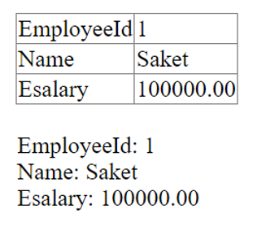

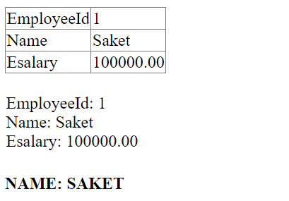

**Practical 10a**

**Aim:** Create a web application to demonstrate JS Bootstrap Button.

**Design & Code:**

<%@ Page Language="C#" AutoEventWireup="true" CodeBehind="Bootstrap.aspx.cs" Inherits="Pract10a.Bootstrap" %>

<!DOCTYPE html>

<html xmlns="http://www.w3.org/1999/xhtml">

<head runat="server">

<title>Bootstrap example</title>

<meta charset="utf-8"/>

<meta name="viewport" content="width=device-width, initial-scale=1"/>

<%--<link rel="stylesheet" href= "https://maxcdn.bootstrapcdn.com/bootstrap/3.4.1/css/bootstrap.min.css"/>

<script

src="https://ajax.googleapis.com/ajax/libs/jquery/3.7.1/jquery.min.js">

</script>

<script src="https://maxcdn.bootstrapcdn.com/bootstrap/3.4.1/js/bootstrap.min.js">

</script> --%>

<link href="https://cdn.jsdelivr.net/npm/bootstrap@5.0.2/dist/css/bootstrap.min.css" rel="stylesheet" integrity="sha384-EVSTQN3/azprG1Anm3QDgpJLIm9Nao0Yz1ztcQTwFspd3yD65VohhpuuCOmLASjC" crossorigin="anonymous"/>

<script src="https://cdn.jsdelivr.net/npm/bootstrap@5.0.2/dist/js/bootstrap.bundle.min.js" integrity="sha384-MrcW6ZMFYlzcLA8Nl+NtUVF0sA7MsXsP1UyJoMp4YLEuNSfAP+JcXn/tWtIaxVXM" crossorigin="anonymous"></script>

<script src="https://cdn.jsdelivr.net/npm/@popperjs/core@2.9.2/dist/umd/popper.min.js" integrity="sha384-IQsoLXl5PILFhosVNubq5LC7Qb9DXgDA9i+tQ8Zj3iwWAwPtgFTxbJ8NT4GN1R8p" crossorigin="anonymous"></script>

<script src="https://cdn.jsdelivr.net/npm/bootstrap@5.0.2/dist/js/bootstrap.min.js" integrity="sha384-cVKIPhGWiC2Al4u+LWgxfKTRIcfu0JTxR+EQDz/bgldoEyl4H0zUF0QKbrJ0EcQF" crossorigin="anonymous"></script>

</head>

<body>

<form id="form1" runat="server">

<div>

<strong>Bootsrap Button Styles in web Page<br />

<br />

</strong>

</div>

<asp:Button ID="Button1" runat="server" CssClass="btn-primary" Text=".btn-primary" />

<asp:Button ID="Button2" runat="server" CssClass="btn-warning" Text=".btn-warning" />

<br />

<br />

<asp:Button ID="Button4" runat="server" CssClass="btn-danger" Text=".btn-danger" Width="112px" />

<br />

<br />

<asp:Button ID="Button5" runat="server" CssClass="btn-primary disabled" Text=",btn-disabled" />

<asp:Button ID="Button6" runat="server" CssClass="btn-primary active" Text=".active" />

<br />

<br />

<asp:Button ID="Button7" runat="server" CssClass="btn-primary btn-lg" Text=".btn-lg" />

<asp:Button ID="Button8" runat="server" Text=".btn.xs" CssClass="btn-primary btn-xs" />

<br />

<br />

<asp:Button ID="Button9" runat="server" Text=".btn-block" CssClass="btn-primary btn-block" />

</form>

<h4>NAME: SAKET</h4>

</body>

</html>

**Output:**

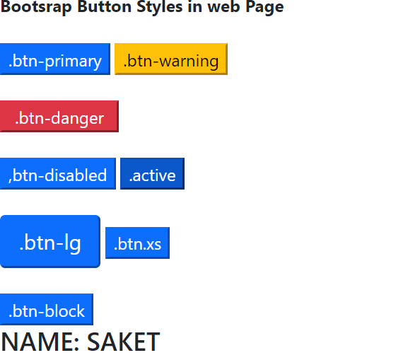

**Practical 10b**

**Aim:** Create a web application to demonstrate use of various Ajax controls

**Design:**

<%@ Page Language="C#" AutoEventWireup="true" CodeBehind="pract 10 B.aspx.cs" Inherits="Practical_10.pract_10_c" %>

<!DOCTYPE html>

<html xmlns="http://www.w3.org/1999/xhtml">

<head runat="server">

<title></title>

</head>

<body>

<form id="form1" runat="server">

<div>

<asp:ScriptManager ID="ScriptManager1" runat="server">

</asp:ScriptManager>

<br />

<h1 style="color:blueviolet">From Outside of Update Pannel:</h1>

<h3>It will refresh the whole page when the button gets pressed.</h3>

Enter The Name :

<asp:TextBox ID="TextBox1" runat="server"></asp:TextBox>

<br />

<br />

<asp:Label ID="Label1" runat="server" Text=""></asp:Label>

<br />

<br />

<asp:Button ID="Button1" runat="server" OnClick="Button1_Click" Text="Get Name" />

<br />

<br />

<br />

<asp:UpdatePanel ID="UpdatePanel1" runat="server">

<ContentTemplate>

<h1 style="color:blueviolet">From Inside of Update Pannel:</h1> <br/>

<h3>It will refresh the only sub part of page when the button gets pressed.</h3>

Enter The Surname:

<asp:TextBox ID="TextBox2" runat="server"></asp:TextBox>

<br />

<asp:Label ID="Label2" runat="server" Text=""></asp:Label>

<br />

<br />

<asp:UpdateProgress ID="UpdateProgress1" runat="server" DisplayAfter="1000" AssociatedUpdatePanelID="UpdatePanel1">

<ProgressTemplate>

Please Wait ...

<br />

<asp:Image ID="Image1" runat="server" ImageUrl=”~image” />

</ProgressTemplate>

</asp:UpdateProgress>

<asp:Button ID="Button2" runat="server" OnClick="Button2_Click" Text="Get Surname" />

<br>

</br>

<br />

</ContentTemplate>

</asp:UpdatePanel>

<asp:UpdatePanel ID="UpdatePanel2" runat="server">

<ContentTemplate>

Time :

<asp:Label ID="Label3" runat="server"></asp:Label>

&nbsp;<asp:Timer ID="Timer1" runat="server" Interval="10000" OnTick="Timer1_Tick1">

</asp:Timer>

<br />

</ContentTemplate>

</asp:UpdatePanel>

<br />

</div>

</form>

<h4>NAME: SAKET</h4>

</body>

</html>

**Output:**

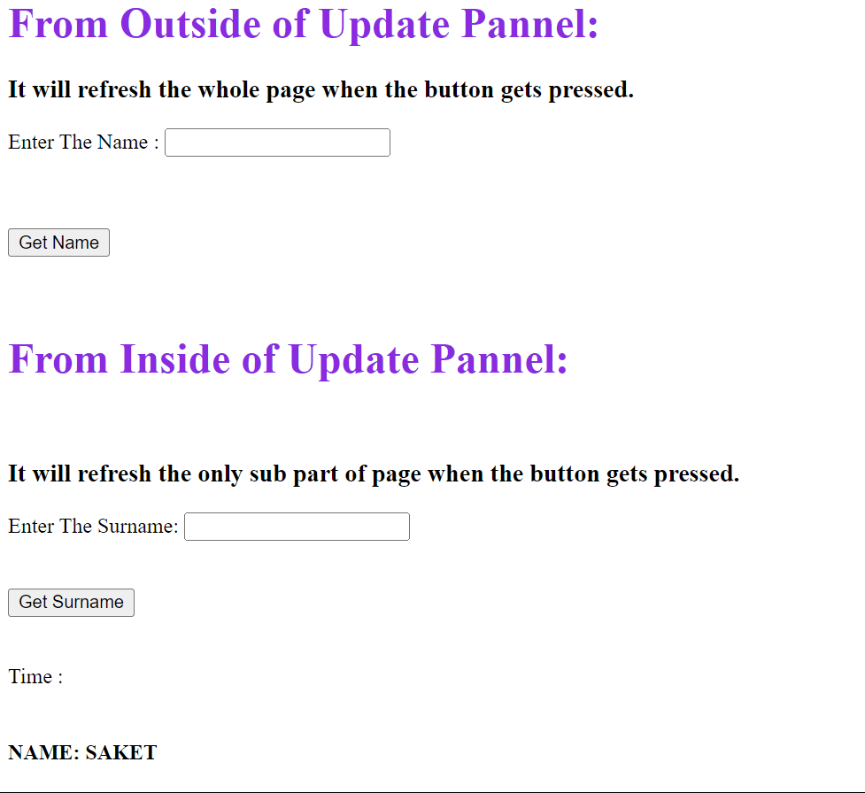

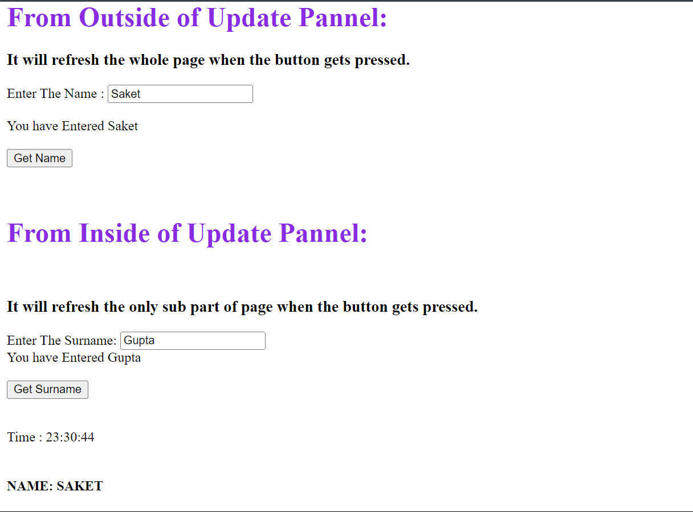

**Practical 10c**

**Aim:**

**Design:**

**Code:**

**Output:**